EFFECTIVENESS OF VIDEO ASSISTED TEACHING MODULE REGARDING KNOWLEDGE ON PRACTICE ON SURGICAL FOMENTATION OF PATIENTS WITH DIABETIC FOOT AMONG STAFF NURSES WORKING IN VINAYAKA
MISSION KIRUPANANDA VARIYAR MEDICAL
COLLEGE HOSPTAL, SALEM

By
SYAM MOHANLAL
M.Sc (NURSING) IInd YEAR

Submitted to
Vinayaka Missions University in the Partial Fulfillment of the
DEGREE OF MASTER OF SCIENCE IN NURSING
(Medical - Surgical Nursing)


VINAYAKA MISSION’S ANNAPOORANA COLLEGE OF NURSING,
SALEM, TAMILNADU.

2012
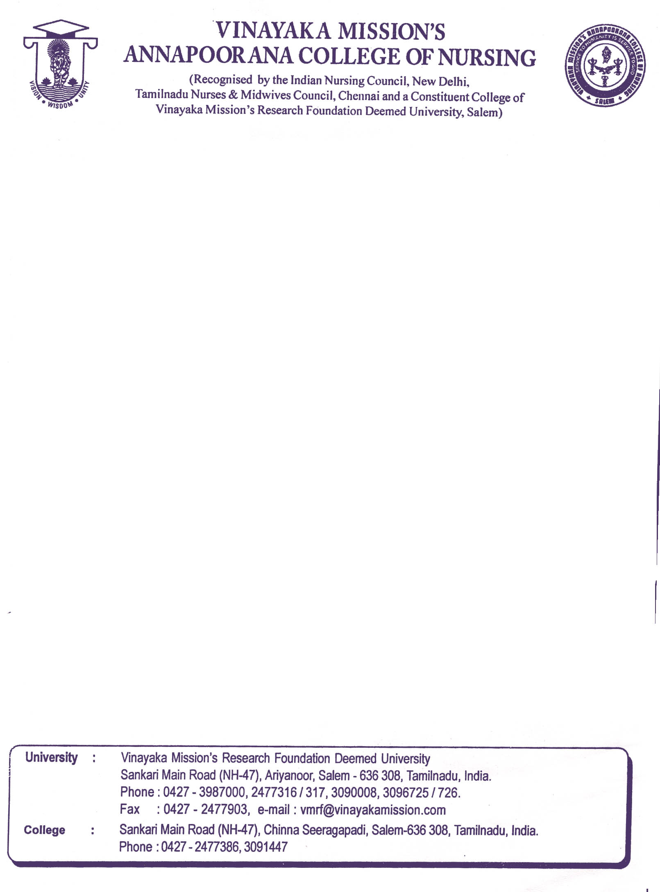

CERTIFICATE
This is to certify that the dissertation “Effectiveness of Video assisted teaching module regarding knowledge on practice on Surgical fomentation of diabetic foot patients among staff nurses working in Vinayaka Mission’s Kirupananda Variyar Medical College Hospital, Salem.” is a bonafide work of Mr. Syam Mohanlal, M.Sc. Nursing IInd year, at Vinayaka Mission Annapoorana College of Nursing, Salem, submitted in partial fulfillment of the requirement for the degree of Master of Science in Nursing (Medical Surgical nursing) from Vinayaka Missions University, Salem.

Dr. (Mrs.) V.SELVANAYAKI Ph.D. (N)
Principal, VMACON
Salem, Tamil Nadu

Register No:
M.Sc. (N) IIst year.

CERTIFICATE

This is to certify that the dissertation,“ Assess the effectiveness of Video assisted teaching module regarding knowledge on practice on Surgical fomentation of patients with diabetic foot among staff nurses working in Vinayaka Mission’s Kirupananda Variyar Medical College Hospital, Salem” was carried out by Syam Mohanlal, M.Sc. Nursing 2nd year (Medical – Surgical Nursing), student of Vinayaka Mission’s Annapoorana College of Nursing, under my guidance.

Guide: Co-Guide:
Mrs.S. Lakshmiprabha MSc (N) Mrs. M. Sumathi, MSc (N),
H.O.D Med-Surg(N) dept. Assistant Professor
V.M.A. College of Nursing V.M.A. college of Nursing,
Salem. Salem.

Signature : Signature:

Date : Date :

ACKNOWLEDGEMENT
Success is the fruit of hard work. The success was possible due to the collective efforts of so many personality to whom I express my gratitude.
I am nothing in front of God Almighty, who laid his hand upon me and provided me the wisdom and understanding to complete this manuscript.
First, I am immensely grateful to Dr. A. Shanmuga Sundaram, Chancellor, Vinayaka Missions University, for giving me an opportunity to undertake the course under the Vinayaka Missions University.
I express my deep sense of gratitude and appreciation to the vice chancellor, prof. Dr. V.R. Rajendran Ph.D., Vinayaka Missions University, Salem for providing opportunity to conduct this study.
I thank all the members of the management of Vinayaka Mission’s University for their good wishes and timely support for completion of study.
I extent my deep sense of gratitude and respect to the principal, Dr. (Mrs.) V. Selvanayaki Ph.D., (N) for her constant guidance, highly instructive suggestion, precious advice, as well as providing all possible facilities for successfully carrying out this study, inspite of her busy schedule of work.
My sincere thanks to my guide, Mrs.S. Lakshmiprabha, M.Sc(N), H.O.D of Medical – Surgical Nursing department, for her valuable guidance, highly instructive suggestion, constant encouragement, personal interest, patience and timely help during the entire course of study.
My sincere thanks to my co-guide, Mrs.M.SUMATHI,M.Sc(N), Assistant Professor, VMACON-Salem for her constant encouragement and valuable guidance during the course of study.
I express my sincere thanks to the bio – statistician Mr. V. Mani, M.Phil (Biostatistics) for helping me in analyzing the data for this study.
I take this opportunity to thank all the Research Committee members of Vinayaka Mission’s Annapoorna College of Nursing, Salem for their constructive criticism and valuable suggestions, while contributing towards the completion of the study.
I am immensely thanking The Medical Director, Dean of the respective hospital, Salem for the opportunity provided to me to conduct the study in their hospitals.
I express my heartfelt gratitude to all the staff nurses who have participated in the study. Without their co-operation, the study would not have been completed.
I extend my sincere thanks to Mr. Shanmugam and Mr. Jayaraju, librarians, Vinayaka Mission’s Annapoorana College of Nursing, Salem for extending necessary library facilities throughout the study.
My warm appreciation to all those who have helped me directly and indirectly to complete the study. Finally yet importantly, I express my gratitude to my parents and friends for their encouragement and support through the project.
(Syam Mohanlal)

Abstract

A pre-experimental research design with pre and post test without control group & experimental approach was undertaken in Vinayaka missions Medical College hospital, Salem, from 20/09/10 to 02/10/10. The data were collected from 48 staff nurses selected through purposive sampling technique to assess the effectiveness of VATM regarding knowledge on practice on surgical fomentation of patients with diabetic foot among staff nurses through closed ended questionnaires.
Findings revealed that highest percentage (67%) of staff nurses were in the age group of 21-25 years, and 63% of the staff nurses were female, majority (61%) were B.Sc (N), Higher percentage (44%) of staff nurses were working in different wards such as medical ward. Most (92%) of staff nurses had not attended in service education programme.
Overall pretest mean score was 12.73 ±1.23 which is 42% whereas post test mean score was 19.19 ± 2.17 which is 64% of total score depicting the overall difference in mean percentage was 22% showing the effectiveness of video assisted teaching module. Analysis revealed that highest effectiveness (26%) was for the area “Surgical fomentation” and the lowest effectiveness (17%) was for the area “articles required”. Highly significant difference was found between pre and post test knowledge scores and no significant association was found between knowledge scores in relation to demographic variables.

TABLE OF CONTENTS
Chapter No. | Topics | Page  No.
I | Introduction  - Need for study  - Statement of the problem  - Objectives  - Operational definition  - Delimitation  - Hypotheses  - Theoretical framework  - Summary | 1-11
II | Review of literature  - Introduction.  - Diabetes Mellitus..  - Diabetic foot.  - Incidence and prevalence of Diabetes mellitus and diabetic foot  - Surgical fomentation  - Nurse’s role on practice of Surgical fomentation  - Studies related to VATM on surgical fomentation..  - Summary. | 12-23
III | Methodology  - Research design and approach  - Setting of the Study  - Population  - Sample  - Sample size  - Sampling Technique  - Criteria for Selection of Sample  - Methods of data collection  - Data Collection Procedure  - Planned Data Analysis  - Summary | 24-35
IV | Analysis and interpretation  Section I Description of demographic data of the staff nurses . | 36-73
Section II
Assessment of the knowledge on practice of staff nurses regarding surgical fomentation of diabetic foot patients before implementation of Video assisted teaching module
Section III
Assessment of the effectiveness of VATM
- Area wise comparison of mean, SD and mean percentage of pre and posttest knowledge scores of the staff nurses.
- Line graph comparison of pre and post test knowledge scores of the staff nurses regarding Surgical fomentation.
- O-give comparison of pre and post test scores of staff nurses regarding Surgical fomentation.
- Comparison of level of knowledge of pre and post test scores of the staff nurses regarding surgical fomentation of diabetic foot patients.
- Item wise analysis of correct responses of various items during pre and posttest.
Section IV
Comparison of the effectiveness of VATM with demographic variables of the staff nurses regarding surgical fomentation.
Section V
- Testing of Hypotheses
- Summary
V | Discussion, Summary, Conclusions, Implications and Recommendations  - Discussion  - Summary  - Conclusion  - Implication  - Recommendation  - Summary | 74-89
 | Bibliography | 90
 | Annexures | i-xxx

LIST OF TABLES
Table No. | Title | Page No.
3.1 | Area wise description of number of questions. | 29
3.2 | Percentage of score revealing level of knowledge. | 29
4.2.1 | Area wise distribution of Mean, SD and Mean Percentage of pre test knowledge scores of staff nurses regarding knowledge on practice on surgical fomentation of diabetic foot patients | 43
4.3.1 | Area wise comparison of Mean, SD and Mean Percentage of pre and post test knowledge scores of staff nurses regarding knowledge on practice on surgical fomentation of diabetic foot patients. | 45
4.3.2 | Item wise comparison of pre and post test scores for correct response in the area diabetic foot on the knowledge among staff nurses. | 53
4.3.3 | Item wise comparison of pre and post test scores for correct response in the area of surgical fomentation on the knowledge among staff nurses | 55
4.3.4 | Item wise comparison of pre and post test scores for correct response in the area of mechanism of physiological effects of surgical fomentation on the knowledge among staff nurses. | 56
4.3.5 | Item wise comparison of pre and post test scores for correct response in the area of articles required on the knowledge among staff nurses | 58
4.3.6 | Item wise comparison of pre and post test scores for correct response in the area of procedure on the knowledge among staff nurses | 60
4.3.7 | Item wise comparison of pre and post test knowledge scores for correct responses in the area aftercare among staff nurses. | 62
4.3.8 | Item wise comparison of pre and post test knowledge scores for correct responses in the area merits among staff nurses. | 63
4.4.1 | Comparison of mean, SD and mean percentage of pre and post test knowledge scores staff nurses regarding surgical fomentation according to their age. | 64
4.4.2 | Comparison of mean, SD and mean percentage of pre and post test knowledge scores of staff nurses regarding the care of patients with surgical fomentation according to their age. | 65
4.4.3 | Comparison of mean, SD and mean percentage of pre and post test knowledge scores of video assisted teaching module regarding surgical fomentation among staff nurses according to their educational status | 66
4.4.4 | Comparison of mean, SD and mean percentage of pre and post test knowledge scores of staff nurses regarding surgical fomentation according to their department of working | 67
4.4.5 | Comparison of mean, SD and mean percentage of pre and post test knowledge scores of staff nurses regarding surgical fomentation according in service education attended | 68
4.5.1 | Paired ‘t’-test for pre and post test knowledge scores of video assisted teaching module regarding surgical fomentation | 70
4.5.2 | Association between post test knowledge scores of video assisted teaching module regarding surgical fomentation among staff nurses with their selected demographic data | 72

LIST OF FIGURES
Figure No. | Title | Page No.
1.1 | Theoretical framework showing effectiveness of VATM regarding knowledge on practice on surgical fomentation of patients with diabetic foot among staff nurses. | 10
4.1.1 | Bar diagram showing percentage wise distribution of staff nurses according to their age group. | 36
4.1.2 | Pie diagram showing percentage wise distribution of staff nurses according to their sex. | 37
4.1.3 | Pie diagram showing percentage wise distribution of staff nurses according to their education. | 38
4.1.4 | Bar diagram showing percentage wise distribution of staff nurses according to their department of working. | 39
4.1.5 | Pie diagram showing percentage wise distribution of staff nurses according to their number of in-service education programme attended. | 40
4.3.1 | Line diagram showing the comparison of pre and posttest knowledge scores | 47
4.3.2 | O-give curve showing comparison of pre and posttest knowledge scores | 49
4.3.3 | Bar diagram showing the comparison of level of knowledge of pre and post knowledge scores of the staff nurses regarding surgical fomentation of diabetic foot patients. | 51

LIST OF ANNEXURES

Annex. No. | ANNEXURE | Page No.
I  II  III  IV  V  VI  VII  VIII  ix | Letter seeking permission to conduct the study  Letter seeking permission to conduct reliability  Letter seeking expert opinions and suggestions for content validity  Certificate of validation  Closed ended questionnaire  Answer key of closed ended questionnaire  List of experts  Lesson plan on video presentation  Video Compact disc | i  ii  iii  iv  v  vi  vii  viii  xxx

INTRODUCTION

Diabetes Mellitus is a genetically and clinically heterogenous group of chronic systemic disorder of various causes. Disturbance of Carbohydrate, protien and lipid metabolism occur because of deficiency of insulin (Donna D, 1995 ) According to Luckmann and Sorenson (1998) common signs and symptoms of Diabetes Mellitus include polyuria, polydypsia, polyphagia, and other symptoms include fatigue, weakness, sudden vision changes, tingling or numbness in hands or feet, dry skin, skin lesions or wound that are slow to heal, and recurrent infection

Need for Study
Barbare K (1999) stated that Diabetes Mellitus is a metabolic disorder of the pancreas in which glucose intolerance result from varying degree of insulin deficiency .

The WHO projects that, by 2010 more than half of Diabetic suffers in world. Diabetes affects 139 millions people worldwide, and estimate for 2025 suggest that this number will rise to 380 million. (WHO, 2008).

Asia is home to four of the world’s five largest Diabetic populations. (Hodgson A. D, 2006). India has about 42 million people with Diabetes putting it first in the list of the 10 nations most affected by this disease. The present projection indicates that India shall continue to hold the same position up to 2025.( Shandikar, U., 2009). In Tamil Nadu, the incidence of Diabetes Mellitus ranges from 30 to 40 per thousand of the population. (The Hindu, 2009 )

Lancet, (2005) stated that up to 25% of those with Diabetes will develop a foot ulcer. More than half of all foot ulcers will become infected requiring hospitalization and 1 in 5 will require an amputation. Every 30 seconds, somewhere in the world a limb is lost as a consequence of Diabetes. After a major amputation, 50% of patients will have either limb ambutated within 2 years.

It reveals that 15-20% of patients with Diabetes Mellitus in Asia will develop Diabetic Foot. And upto 25% of those with Diabetes will develop Foot Ulcer in India. ( Shandikar K.,2006 )

Since Diabetic Mellitus is growing in Tamil Nadu, two of 100 Diabetic patients are estimated to suffer from a foot ulcer every year. Amputation rates vary considerably . (The Hindu., 2008 ). Foot Ulcers or gangrene were observed in 11.6% of a low level of quality of life was registered in many patients, mostly due to difficult living conditions. (Vides H .et al.,2011 ) Major lesions , amputation, Foot ulcers and predisposing lesions, callus or fungal infection were present in 48.5% of patients. (Simmons D et al., 2005 )

Diabetic foot infections are infections that can develop in the skin, muscles or bones of the foot as a result of the nerve damage and poor circulation that is associated with Diabetes. ( American Diabetes Association ,2004 ). According to American Academy of Physicians (2001 ), Diabetes affects the body’s ability to control the levels of sugar in the blood and can affect the flow of blood and lead to ulcers , which are sores that appear in the bottom

Fisher T.K, (2001) stated that the major complications of Diabetic foot are neuropathy, skin changes , calluses, foot ulcers, poor circulation, amputation of the feet or big toe.

According to Frykberg R.G (1998 ) foot ulcerations and their sequence remain a major source of morbidity for patients with Diabetes Mellitus often leading to infections, osteomyelitis or gangrene . Those lesions have consistently been ascertained as significant risk factors for subsequent lower extremity amputation.

Diabetic peripheral neuropathies are a variety of syndromes, which affect sensory, autonomic and motor nerve function. The commonest form, distal symmetric sensory poly neuropathy, is a major risk factor for foot ulceration which may be eventually lead to lower limb amputation. According to the report of Tapp R.J et al (2002), prevalence of peripheral neuropathy was 13.1% in those with known Diabetes and 7.1% in those with newly diagnosed (NDM ). The prevalence of peripheral vascular disease was 13.4% in known diabetes mellitus and 6.9% in newly diagnosed diabetes mellitus of those with Diabetes 19.6% were at risk of foot ulceration.

Fujisawa (2002) described that nursing care in Diabetic foot which includes monitoring the patients, within 7 days of admission to the hospital, all patients should have a mandatory urine test. On being tested positively, the diabetic patient should be given proper management. Keeping patient’s blood sugar level under good control can help to prevent or delay foot complications. Inspect patients feet daily, wash and moisturize daily. For preventing complications such as smooth corns and calluses, after giving sponge bath, use a pumice stone to gently rub in one direction, smoothing off corns or calluses

Surgical fomentation is the major nursing care in patients with Diabetic Foot. Surgical Fomentation is the hot moist application over an open wound in aseptic conditions. Purpose of the surgical fomentation is to increase the blood supply on inflamed and infected area of foot, to aid the process of resolution , suppuration and repair.(Thressyamma, 2003).

Tsuchiya R, Fujisawa N in 2002 stated in a study that for centuries the treatment of foot lesions were ointment application and fomentation. Surgical Fomentation may helps to increase the blood supply to an inflamed and infected area. Owa J.A in 1992 had conducted a study and says that the hot fomentation is the recommended care for cellulitis and diabetic foot.

Fischer T.K, Armstrong in 2008 said that Diabetic Foot disease frequently leads to substantial long term complications, imposing a huge socio economic burden on available resources and health care system . Individuals with Diabetic Foot infections warrant optimal surgical fomentation to affect limb salvage, prevent amputation, aggressive short term care plans are required.

Ambrosen A, Lehnert H, Lobman F, (2004) have quoted in their study that complications can be successfully treated by appropriate wound surgical fomentation, metabolic control and antibiotic intervention.

During the clinical experience, investigator observed that surgical fomentation in patients with diabetic foot should be improved. Therefore the researcher is interested to study the effectiveness of Video Assisted Teaching Module (VATM ) regarding surgical fomentation on knowledge on practice among patients with diabetic foot admitted in selected hospitals, Salem

Statement of Problem
A study to assess the effectiveness of video assisted teaching module (VATM) regarding knowledge on practice on surgical fomentation of patients with diabetic foot among staff nurses working in Vinayaka Mission Kirupananda Variyar medical college hospital, Salem

Objectives
- To assess the Knowledge on practice of staff nurses regarding the surgical fomentation in Diabetic foot before the implementation of Video assisted teaching module.
- To assess the effectiveness of VATM on surgical fomentation among staff nurses working in selected hospitals.
- To compare the effectiveness of video assisted teaching module with demographic variables of staff nurses.

Operational Definitions
Assess :
Statistical measurement of knowledge on practice scores regarding the surgical fomentation in diabetic foot obtained through structured interview schedule.
Effectiveness
Refers to the significant gain in knowledge on practice scores as determined by significant difference in pre test and post test scores of diabetic foot patients

VATM
It is a video that allows the diabetic foot patients to learn themselves regarding the cleaning and application of hot moist fomentation pad over an open wound under aseptic conditions.

Knowledge on practice
Defined as the correct written responses of diabetic foot patients to the knowledge on practice items in the structured interview schedule.

Surgical Fomentation
It is a hot moist application over an open wound in foot of patients with Diabetes Mellitus.

Diabetic Foot
Diabetic foot infections are infections that can develop in the skin, muscles or bones of the foot as a result of the nerve damage and poor circulation that is associated with Diabetes.

Patients
Any diabetic patient coming with an foot ulcer and age above 35 years

Hypotheses
H₁- There is a significant difference between pre test and post test knowledge on practice scores of diabetic foot patients regarding surgical fomentation in diabetic foot patients.
H₂ - There is a significant association between post test knowledge on practice scores of diabetic foot patients and their selected demographic variables.

Delimitations:
Study is limited to diabetic patients who will be,
- willing to participate in the study.
- present during the time of data collection.
- admitted in medical and surgical units
- able to speak and understand Tamil

Theoretical framework
Wood and Haber (2006) states that “Theoretical framework is a structure of concepts that exists in the literature, a readymade map for the study.“

The study was based upon J. W Kenny’s open system model. All living systems are opened in that , there is a continual exchange of matter, energy and information. Open system gives varying degree of interaction with the environment from which the system receives input and gives back output in the form of matter, energy and informations. For survival, all systems must receive varying types and amount of matters, energy and information, from the environment.

The main concept of Kenny’s open system model is input, throughput, output and feedback. It open system theory input refers to matter, energy and information that enter in the system through its boundary. Throughput is processing the input; the system returns the output (matter, energy and information ) to the environment in an altered state. Feedback refers to information of environment responses to the systems; output is used by the system in adjustment, correction and accommodation to the interaction with the environment.

Input
Input refers to the information related to surgical fomentation in care of Diabetic foot. It include
- Structured Interview schedule regarding Surgical Fomentation.
- Video Assisted Teaching Presentation in various aspects of Surgical Fomentation
- Meaning
- Articles required
- Indications
- Contra indications
- Procedure
- Aftercare

Throughput
In the present study the throughput considered for processing the input are
- Pretest by using cosed ended questionnaire or Surgical Fomentation
- Video Assisted Presentation in various aspects of Surgical Fomentation
- Post test by closed ended questionnaire to assess the effectiveness of Video assisted teaching module regarding Surgical Fomentation

Output
The expected outcome will be obtained by assessing the knowledge on practice through closed ended questionnaire . The output is considered as the gain in knowledge obtained through processing of pretest through Structured Interview Schedule.

Feedback
It can be assessed through the statistical measurement difference of scores obtained by subjects through pretest and post test questionnaires

Out put
Through put
Input
Demographic Variables
Very good
Post test knowledge
On Practice
Among with Diabetic Patients
- Pretest
- Presentation of
Video Assisted teaching Module
- Posttest
- Closed Ended Questionnaire
- VATM regarding surgical fomentation
- Definition
- Purposes
- Articles
- Indications
- Contraindications
- Preliminary assessment
- Physiological effect
- Procedure
- Aftercare
- Merits

- Age
- Gender
- Occupation
- Monthly Income
- Marital Status
- Education
- Duration of Illness
- Type of Family
- Residence Place
Good

Average
Very poor

Feedback
Y-X=E (Y=Posttest score, X=Pretest score and E=effectiveness of VATM
- t-test between pretest and posttest KSc
- Chi-square test between posttest and demographic variables

FIG.1.1 Theoretical framework on knowledge of Patients regarding Surgical Fomentation on W Kenny’s Opens System Model

Summary
This chapter deals with Need for study, Statement of problem, Objectives, Operational definition, assumption, Delimitation, Theoretical framework.

REVIEW OF LITERATURE
A review of literature is a written summary of the state of existing knowledge on a research problem. The task of reviewing research literature involve the identification, selection, critical analysis and written description, of existing information on a topic. (Polit and Hungler,2003)
The review of literature is defined as a broad comprehensive in depth, systemic and critical review of scholarly publications, unpublished scholarly print materials, audiovisual materials and personal communications.
Review of literature is an important step in the development of a research project. It involves the systematic identification, location and survey of written material that contain valid information on research problems. Review of literature is done for the present study and is presented in the following.
- Introduction to Diabetes Mellitus
- Prevalence and Incidence of Diabetes Mellitus
- Diabetic Foot
- Prevalence and Incidence of Diabetes Mellitus and diabetic foot
- Surgical Fomentation
- Nurses role on Practice of Surgical Fomentation
- Studies related to VATM regarding Surgical fomentation
Introduction to Diabetes Mellitus
Diabetes is one of the most common non communicable disease. It is the fourth or fifth leading cause of death in most developed countries and there is substantial incidence that it is epidemic in many developing and newly industrialized nations thus, posing a serious threat to be met within the 21st century ( Shashan K R Joshi,1999 )
Smeltzer C, Bare B. G, (2000) stated that Diabetes mellitus is a group of metabolic disease characterized by elevated levels of glucose in the blood.
According to Luckmann and Sorenson (1998) common signs and symptoms of Diabetes Mellitus include polyuria, polydypsia, polyphagia, and other symptoms include fatigue, weakness,sudden vision changes, tingling or numbness in hands or feet, dry skin, skin lesions or wound that are slow to heal, and recurrent infection.
Barbare K (1999) stated that Diabetes Mellitus is a metabolic disorder of the pancreas in which glucose intolerance result from varying degree of insulin deficiency.
According to Lewis, Heitremper, Dirkson et al., (2000) Diabetes Mellitus is a multisystem disease related to abnormal insulin production, impaired insulin utilization, or both.
Diabetes mellitus is a genetically and clinically heterogenous group of chronic systemic disorder of various causes. Disturbance of Carbohydrate, protein and lipid metabolism occur because of a deficiency of insulin (Donna D, 2005)
It is estimated that there would be more than 700 thousand new diabetic per year in 24-74 years old Chinese population were 1.3 billion in the early 21st century
Prevalence and Incidence of Diabetes Mellitus
Cockram C S (2000) reported that Asia-pacific region is at the for front of the current epidemic of Diabetes . There are currently 30 million people with DM in the western pacific region alone.
Prevalence of DM type II in the adult population of Austria’s (9.9%) is moderately high and similar to that observed in our country and other white populations in the world. More than half of patients with Diabetes Mellitus are unaware of their condition. Thus planning strategies for and early diagnosis would be helpful for the high risk population. (Botas Cervero P, et al.2003).
Sayeed M.A Alil et al.(1997) conducted a survey about prevalence ofDiabetes Mellitus in Bangladesh found to be 11.8% in rural and 4.8% in urban population respectively.
Mather H.M and Keen H (2006) have reported in their study that diabetes was more prevalent among vegetarian people (2.1-2.8%) than non vegetarian people.

According to the report of Tapp RJ. Et al. (2002) prevalence of peripheral neuropathy was 13.1% in those with known diabetes (KMD) and 7.1% in those with newly diagnosed (NDM). The prevalence of PVD was 13.9% in KDM and 6.9% in NDM of those with diabetes 19.6% were at risk at foot ulceration.
Shi HL, Fang JC , Zhu ,(2007) have done a study to suggests that risk factors associated with diabetes in old age , hypertension and an overweight condition. Dhadvel D. et al . (1998) have done a random survey for determining the prevalence of Diabetes Mellitus was conducted in the population aged 40 years and above was 4.86% was found to be positively associated with increasing age.
The WHO projects that, by 2010 more than half of Diabetic suffers in world. Diabetes affects 139 millions people worldwide, and estimate for 2025 suggest that this number will rise to 380 million. (WHO, 2008).
Asia is home to four of the world’s five largest Diabetic populations. (Hodgson A. D, 2006). India has about 42 million people with Diabetes putting it first in the list of the 10 nations most affected by this disease. The present projection indicates that India shall continue to hold the same position up to 2025.( Shandikar, U., 2009).
In Tamil Nadu, the incidence of Diabetes Mellitus ranges from 30 per thousand of the population. (The Hindu, 2009 )

Diabetic Foot
Diabetic foot infections are infections that can develop in the skin, muscles or bones of the foot as a result of the nerve damage and poor circulation that is associated with Diabetes. (American Diabetes Association, 2004)
Foot ulcers are one of the main complications of the Diabetes, according to American Academy of Physicians (2001). Diabetes affects the body’s ability to control the levels of sugar in the blood and can affect the flow of blood and lead to ulcers, which are sores that appear in the bottom
Lancet , (2007) stated that upto 25% of those with Diabetes will develop a foot ulcer. More than half of all foot ulcers will become infected requiring hospitalization and 1 in 5 will require an amputation. Every 30 seconds , somewhere in the worlds a limb is lost as a consequence of Diabetes. After a major ambutation , 50% of patients will have either limb ambutated within 2 years.
It reveals that 15-20% of patients with Diabetic Mellitus in Asia will develop Diabetic Foot. And upto 25% of those with develop foot ulcer in India.(A.D Hodgson, Kshitiji, Uma Shandikar,.2006)
Since Diabetes Mellitus is growing in Tamil Nadu , two of 100 diabetic patients are estimated to suffer from a foot ulcer every year. Amputation rates vary considerably. (The Hindu.,2008).

Foot ulcers or Gangrene were observed in 11.6% of a low level of quality of life was registered in many patients, mostly due to difficult living conditions. Major lesions, amputation, foot ulcers and predisposing lesions, callus or fungal infection were present in 48.5% of patients. (Simmons D et al.,2005)
Fischer T.K ,(2006)stated that the major complications of diabetic foot are neuropathy, skin changes, calluses, foot ulcers, poor circulation, amputation of the feet or big toe. Foot ulcerations and their sequence remain a major source of morbidity for patients with diabetis mellitus often leading to infections, osteomyelitis or gangrene. Those lesions have consistently been ascertained as significant risk factors for subsequent lower extremity amputation.( Fischer T. K, Frykberg R.G, 1998)
Diabetic peripheral neuropathies are a variety of syndromes, which affect sensory, autonomic and motor nerve function. The commonest form, Distal symmetric sensory poly neuropathy, is a major risk factor for foot ulceration which may be eventually lead to lower limb amputation. According to the report of Tapp R.J et al (2002), prevalence of peripheral neuropathy was 13.1% in those with known Diabetes and 7.1% in those with newly diagnosed (NDM ). The prevalence of PVD was 13.4% in KDM and 6.9% in NDM of those with Diabetes 19.6% were of risk at foot ulceration.
Fujisawa (2002) described that nursing care in Diabetic foot which includes monitoring the patients , within 7 days of admission to the hospital, all patients should have a mandatory urine test. On being tested positively, the diabetic patient should be given proper management. Keeping patient’s blood sugar level under good control can help prevent or delay foot complications. Inspect patients feet daily, wash and moisturise daily. For preventing complications such as smooth corns and calluses, after giving sponge bath, use a pumice stone to gently rub in one direction, smoothing off corns or calluses
Surgical Fomentation
Surgical fomentation is the application of moist heat over an open wound under strict aseptic conditions. It is the application of hot moist fomentation pad over an open wound under strict aseptic conditions.( Shakunthala Sharma, 2007)
According to Sister Nancy.(2005), the main purposes of Surgical fomentation are to soften extenuates, to hasten suppurative process, to promote healing process, to reduce swelling, to reduce pain, to provide a soothing effect, to reduce inflammation. To soften extenuates.
The indication of Surgical fomentation are diabetic foot, edemas and inflammations, strains, local abscesses, arthritis and stiff joints and any trauma, The contra indications are impaired vital function, impaired perception, Impaired metabolism, acute inflammation, edema associated with venous or lymphatic diseases, headache, high Temperature, malignancy or the patient is infant or very old.(Banks A S, Meglamry E D , 2009)
Clement (2006) stated that the physiological effects of Surgical fomentation are vasodilation, increased blood circulation, increased metabolism, increased blood viscosity, hyperthermia, increased muscle relaxation
Toikke T, et al. (2007) stated that the preliminary assessment of patient before doing Surgical fomentation are to assess the general condition of the patient, check the physicians order, check the specific precautions if any, the available articles in the patient’s unit, the consciousness and availability and ability to follow instructions. Watch for the signs like swelling, redness, and any drainage, provide privacy and drape the patient, check the temperature of water after pouring into basin, using lotion thermometer. The temperature should be 105⁰F-115⁰F, check the medication of patient
Thressyamma (2005) describes the articles required for surgical fomentation are a clean trey containing bottles of spirit, binder, bandages, pins, adhesive plaster, scissors, kettle with water heated to 105⁰⁻115ºF, solution needed are normal saline, plain water, boric acid2%, Mackintosh, towel, antiseptic solutions, adhesives and scissors if required, lotion thermometer, hot water bag, gloves for removing soiled dressing
A sterile bin containing gown , mask, and cap. A sterile tray for surgical dressing, another sterile tray for surgical fomentation including 2 dissecting forceps, bowl containing sterile winger, fomentation pads, gauze pad, big piece of cotton wool, gloves, water proof covering and a hand washing tray containing soap and water, towel, nail brush.(Thressyamma , 2005)
According to Sharma S.(2005), the procedure of Surgical fomentation include explain the procedure to the patient to win confidence and co-operation, screen for privacy, assemble the equipment to the bedside, strict aseptic principles should be observed, care should be taken to prevent the burning of skin, expose the part to be fomented and protect the bed with mackintosh and towel. Undo the binder or bandage. If the binder is clean keep it under the part. If it is soiled discard it and put a fresh one under the part. Wash the hands well and dry it.
Take off the top dressing and discard it into the kidney tray. Remove the inner dressing and clean the wound by using the dissecting forceps and discard the forceps into the kidney tray. Cover the wound with layers of gauze using another sterile forceps, and take the fomentation pad and dip it in the solution by holding on both ends with the long artery forceps or wrap it in the centre of a wringer which is placed in hot solution. Wring out the solution with the forceps and shake it and apply it over the wound. Water proof covering is placed over the pad which extends half an inch or one inch beyond the pad all around. Apply sterile cotton pad over it and put on the binder.( Sharma. S,2005)
Change the pad every10-15 minutes. A hot water bag can be applied over the fomentation to retain the heat. When changing, a second one is prepared before removing the first and put the second one in place correctly.
When the last pad is removed, the area is dried and usual dressing done and the part is well covered with flannel to prevent it from sudden exposure to cold. If the skin is red during the procedure a thin layer of oil may be applied. Keep the patient comfortable. Surgical fomentation to be done to diabetic foot patients until the ulcer heels. ( Sharma. S, 2005)
According to Piagessi A, et al; (2008) aftercare of surgical fomentation includes replace the articles, record the treatment, date, time, type of fomentation used, length and frequency of removal of pad, condition of wound and the result of the treatment, dry the feet automatically after fomentation, keep the feet warm wearing cotton sacks, inspect feet at least twice a day, apply thin layer of oil if the skin became red after the procedure, dry the feet automatically after the fomentation.
The merits of surgical fomentation are it is less expensive, more effective to prevent infection, less time consuming, more effective in inducing the process of wound healing, it improves the process of blood circulation to the affected area, it is sterile in nature thereby preventing infection, provides soothing effect, reduces pain. (Carrington AL, et al;2001

Nurse’s role on practice of Surgical Fomentation
Luckmann J.(2006), who reported that knowledge on practice status of the staff nurses after implementation of the education program on Surgical fomentation had more effectiveness(26%) on age group of 26-30 years.
Godse T. R (2005) conducted a study among staff nurses regarding their knowledge on practice on surgical fomentation. He found that implementation of video assisted teaching module was effective to all nurses irrespective of their gender
Shandikar K (2007) reveals his findings in a study regarding the knowledge status of staff nurses on diabetic foot care stated that as the education of staff nurses increases, the knowledge level also increases.
Kalyan B (2006) who observed that staff nurses working in the intensive care units are having more knowledge regarding surgical fomentation of patients with diabetic foot.
Eliza P (2007) conducted a study on knowledge of staff nurses regarding diabetic foot care shows that the knowledge level of nurses was irrespective of their attended in-service education

Studies related to VATM regarding Surgical Fomentation
The video assisted teaching module is effective in providing education to staff nurses on surgical fomentation to enhance the quality of care of patients with diabetic foot. Wilkin S. F(2003) has conducted a study and stated that if targeted programme of education is carried out, yielded high rate of success in gaining knowledge by staff nurses
Sandler D. A (1990) and Graeb (2008) have illustrated that providing education, through information books and video will increase the accuracy of the procedure Surgical fomentation.
The related literature and research findings have supported the need for video assisted teaching module for staff nurse who are working in the podiatric wards as they get deep knowledge in the care of diabetic foot. This will encourage the staff nurses to practice Surgical fomentation more on patients with diabetic foot. Hence the study processes to identify whether the video assisted teaching module will increase the knowledge on practice on surgical fomentation among patients with severe diabetic neuropathies and peripheral vascular disease.

METHODOLOGY
The methodology of research indicates the general pattern of organizing the procedure for gathering valid and reliable data for the purpose of investigation. (Kothari C.R,2004).
The methodology of present study includes research design, the choice of research approach, the setting of the study, population, sample, and sampling technique, developing and testing the tool, data collection procedure and method of analysis based on the statement and objectives of the study.
Research design & Approach
The research design refers to the overall plan for obtaining answers to the questions being studied and for handling some of the difficulties encountered during the research process (Polit D.F. & Beck C.T., 2006).
A pre experimental research design with pre and post test without control group and experimental approach was used.
O1 - - - - - - - - -x- - - - - - - - O₂
O₂ ₋ O₁ = E
The symbols used are as follows:
O₁:- Pre test - Assessment of knowledge on practice regarding surgical fomentation through closed ended questionnaire, before implementation of video assisted teaching module.
X: Display of video assisted teaching module on surgical fomentation of diabetic foot patients on staff nurses
O₂:- Post test - Assessment of knowledge on practice of staff nurses regarding surgical fomentation on diabetic foot patients through closed ended questionnaire, after implementation of video assisted teaching module.
E: Effectiveness of VATM regarding surgical fomentation on diabetic foot patients.
Setting of the Study
The study was conducted in Vinayaka Mission Kirupananda Variyar Medical College Hospital, which is located at about 12km away from Salem , is 600 bedded hospital and around 120 staff nurses are working in this hospital.
Population
The population is all elements (individuals, objects or substances) that meet certain criteria for inclusion in a study. The population will depend on the sample criteria and the similarity of subjects in these various settings (Burns N. & Grove S.K., 2002).
In the present study, the population are all the staff nurses who are working in Vinayaka Mission Kirupananda Variyar Medical College Hospital, Salem.
Sample and sampling technique
Sample
Sample is a subset of population selected for a particular study and members of the sample are the subjects. (Polit and Hungler,2002)
Staff nurses working in Vinayaka Mission Kirupananda Variyar Medical college Hospital, Salem.
Sample size
The sample size was approximately 48 staff nurses working in Vinayaka Mission Kirupananda Variyar Medical College Hospital, Salem
Sampling technique
Sampling is the process of obtaining information about an entire population by examining only a part of it (Kothari C.R., 2004).
Purposive sampling technique was used to select the sample for the present study.
Criteria for selection of sample:
Inclusion criteria:
The study is limited to the staff nurses who was,
- available in the hospital at the time of data collection
- of both sexes
- willing to participate in the study
- able to read and write English
I. Methods of data collection
Development of the tool
The tools used for the study was be,
- Closed ended questionnaire to assess the knowledge on practice of staff nurses regarding surgical fomentation of diabetic foot patients .
- Video assisted teaching module regarding surgical fomentation on diabetic foot patients.
Steps for preparing the tool:
i) Review of literature
Books, journals, reports, articles and published studies was used
to develop the tool.
- Preparation of blue print
The blue print of items pertaining to the domain of knowledge was prepared as per the objectives and conceptual framework.
- Preparation of the tool
The tool was prepared based on the blue print and in consultation with the guide.
- Organization of contents of tool
The content of the tool was organized as per the domain of knowledge.
Description of the tool
- Closed ended questionnaire
Closed ended questionnaire consist of two sections.
Section A: It consist of demographic characteristics of sample such as age, gender, educational status, experience, inservice educational programme attended on surgical fomentation of Diabetic Foot patients, department where working.
Section B: It consist of closed ended questions, pertaining to knowledge on practice of staff nurses regarding surgical fomentation on diabetic foot patients such as preliminary assessment, indications, contraindications, physiological effects of surgical fomentation articles required, procedure, aftercare, merits of surgical fomentation. Each item has four options with one most appropriate answer. In each item the correct response carries the score ‘one’ and wrong response carries ‘zero’ score.
Number of question in each area is presented in the following table.
Tab.3.1Area wise description of number of questions
Areas | No. of questions
Introduction to Diabetic foot and surgical fomentation | 11
Physiological effects of surgical fomentation, Preliminary assessment | 04
Articles Required | 04
Procedure | 05
Aftercare and merits | 06

Scoring procedure:
Each item in tool have four options with one correct option. Each correct option carries ‘one score’ and for wrong option ‘zero score’. The level of knowledge was categorized based on the percentage of scores obtained.

Tab.3.2 shows percentage of Scores revealing level of knowledge.
Level of knowledge | Percentage of scores | Actual Scores
Very poor | <21% | 1 -6
Poor | 21-40% | 7 -12
Average | 41-60% | 13 -18
Good | 61- 80% | 19 – 24
Excellent | 81% and above | 25 -30

VATM : Video assisted teaching module
The contents of the video assisted teaching module was organized as follows:
- Introduction
- Diabetic Foot
- Surgical fomentation
- Indications
- Contra indications Physiological effects of Surgical fomentation
- Articles required
- Procedure
- Aftercare
- Merits
v) Consultation with guides, experts and research committee
The tool was given to the guides and experts in various fields such as Medical-surgical nursing, endocrinology, Statistics and research committee. Their opinion and suggestions was taken to modify the tool.
vi) Test for validity and reliability
Validity
Validity is the degree to which an instrument measure what is supposed to measure. (Polit and Beck,2007)
Content validity of the closed ended questionnaire and video assisted teaching module was established by sending the tools to experts from various fields like Medical Surgical Nursing, endocrinology and biostatistician. The tool was modified according to the suggestion and recommendation of experts.
Reliability
The reliability of the measuring instrument is a major criteria for assessing the quality and adequacy. The reliability is concerned with how consistently an instrument measures the concept of interest (Burns N. and Grove.S.K., 2002).
Reliability of the tool was tested by implementing the tool on 5 staff nurses working in Annapoorana Medical College Hospital, other than the sample area. Split half method was used to test the reliability of closed ended questionnaire and test retest method was used to test the reliability of the VATM.
vii) Preparation of the final tool
The final draft of the closed ended questionnaire and the video assisted teaching module was prepared after testing the reliability and validity.

II. Data Collection Procedure
- Ethical consideration
Prior to data collection written permission was obtained from Dean, Vinayaka Mission Kirupananda Variyar Medical college Hospital, Salem. Further, before collection of data informed oral consent was obtained from the staff nurses.
- Period of data collection
The data was collected from 15-09-3 to 29-09- 2011.
- Pre test
Staff nurses were assembled in one room. The procedure and purpose of data collection was explained in detail. Pre test was conducted for 30-45 minutes by using closed ended questionnaire to assess the knowledge on practice of staff nurses regarding surgical fomentation on diabetic foot patients.
- Intervention
Immediately after pre test VATM regarding surgical fomentation on diabetic foot patients was displayed to the staff nurses. Duration of the display was 20 minutes.

- Post test
Evaluation of video assisted teaching module was done by conducting post test, 10 days after the display of the video assisted teaching module by using the same closed ended questionnaire.
Planned Data Analysis
The collected data was organized, tabulated and analyzed based on the objectives of the study by using descriptive statistics Ie, percentage, mean and standard deviation and inferential statistics such as chi square and t test.
The paired ‘ t ’ test was used to find out the difference in knowledge between pre and post test and chi square test was used to test the association between demographic variables with post test knowledge score. The findings of the study was presented in the form of tables and figures.
Summary
This chapter contains research design, the choice of research approach, the setting of the study, population, sample, and sampling technique, development of the tool, data collection procedure and method of analysis based on the statement and objectives of the study.

DATA ANALYSIS AND INTERPRETATION

Analysis is a process of organising and synthesizing data in such a way that the research questions can be answered and hypothesis tested. (Polit and Hungler , 2003)

This chapter deals with the analysis & interpretation of the data collected from the 48 staff nurses working in Vinayaka Mission’s Medical College Hospital, Salem.

The present study was designed to assess the effectiveness of video assisted teaching module regarding knowledge on practice on Surgical fomentation of diabetic foot patients among staff nurses working in Vinayaka Mission’s Kirupananda Variyar Medical College Hospital, Salem.

The data was coded, organised, tabulated and interpreted using descriptive and inferential statistics and was analyzed as per the objectives of the study under the following headings:

Section I:
Description of demographic characteristics of staff nurses.

Section II:
Assessment of the knowledge on practice of staff nurses regarding surgical fomentation of diabetic foot patients before implementation of video assisted teaching module.

Section III:
Assessment of effectiveness of Video assisted teaching module regarding Surgical fomentation
- Area wise comparison of mean, SD, and mean percentage of pre and post test knowledge scores
- Line graph comparison of pretest and post test KSs of staff nurses regarding surgical fomentation
- O- give comparison of pretest and post test KSs of staff nurses regarding surgical fomentation
- Bar diagram comparison of pre and post test on knowledge of staff nurses regarding surgical fomentation
- Item wise comparison of pre and post test knowledge scores of staff nurses regarding surgical fomentation.

Section IV:
Comparison of the effectiveness of Video assisted teaching module with demographic variables of staff nurses regarding Surgical fomentation.

Section V:
Testing of hypothesis
H₁ : There is no significant difference between pre-test and post-test knowledge scores of staff nurses regarding surgical fomentation
H₂ : There is no significant association between post test knowledge scores and selected demographic variables.

Fig.4.1.1 Bar diagram showing percentagewise distribution of knowledge on practice on surgical fomentation of patients with diabetic foot among staff nurses according to their age.

Fig:4.1.2 Pie diagram showing percentage wise distribution of knowledge on practice on surgical fomentation of patients with diabetic foot among staff nurses according to their gender.

Fig:4.1.3. Pie diagram showing percentagewise distribution of knowledge on practice on surgical fomentation of patients with diabetic foot among staff nurses according to their educational status

Fig:4.1.4 Bar diagram showing percentage wise distribution of knowledge on practice on surgical fomentation of patients with diabetic foot among staff nurses according to their department where working.

Fig:4.1.5. Pie diagram showing percentage wise distribution of knowledge on practice on surgical fomentation of patients with diabetic foot among staff nurses according to their inservice education attended

Percentage wise distribution of staff nurses according to their age group depicts that highest percentage (67%) of staff nurses were in the age group of 21-25 years , whereas 25% of staff nurses were in the age group of 26-30 years and 8% of staff nurses were in age group of under study were above 35 years of age. Hence it is interpreted that most of the staff nurses of the under study were young adults might be because of availability of young adult nurses in hospital. (Fig No: 4.1.1)
Percentage wise distribution of staff nurses according to their sex depicts that most of the staff nurses(63%) were female and 37% were males . Hence, it is interpreted that majority of staff nurses under the study were females, might be because of nature of nursing of profession.(Fig.4.1.2)
Percentage wise distribution of staff nurses according to their educational status depicts that the highest percentage(61%) of staff nurses had BSc nursing degree and lowest percentage (10%) of staff nurses had post basic BSc nursing degree. However 29% of staff nurses had diploma in nursing. Hence, it is interpreted that most of the staff nurses under the study were Bsc nursing degree holders which might be because of the present educational trend in nursing.(Fig.4.1.3)
Percentage wise distribution of staff nurses according to their area of working shows that the highest percentage (44%) of staff nurses are working in the medical ward further the lowest percentage (8%) of staff nurses are working in the other areas such as O.T and O.P.Ds. However29% of staff nurses are working in the surgical ward. It seems that most of the nurses are working in the medical ward. It might be because more patients will be admitted in the medical wards so more staffs will be necessary on those wards.
Percentage wise distribution of staff nurses according to their previous source of information shows that majority (92%) of the nurses didn’t attend the inservice program whereas lowest percentage (8%) of nurses who have attended. It seems that most of the nurses had no previous information about surgical fomentation. It might be because of the lack of information.(fig no:4.1.5)

Section – II
Assessment of the knowledge on practice of staff nurses regarding surgical fomentation of diabetic foot patients before implementation of video assisted teaching module.
TableNo.4.2.1: Area wise distribution of mean, SD and mean percentage of pretest scores regarding knowledge on practice on surgical fomentation of patients with diabetic foot among staff nurses.
Area | Max obtainable Score | Pre test score
Area | Max obtainable Score | Mean | SD | Mean (%)
Diabetic foot | 7 | 2.52 | 0.74 | 36
Surgical fomentation | 4 | 1.56 | 0.79 | 39
Physiological effects and preliminary assessment | 4 | 1.58 | 0.87 | 40
Articles required | 4 | 1.75 | 0.76 | 44
Procedure | 5 | 2.56 | 0.79 | 51
After care | 4 | 1.75 | 0.69 | 44
Merits | 2 | 1 | 0.68 | 50
Overall | 30 | 12.73 | 1.23 | 42

Area wise distribution of mean, SD and mean percentage of pre test scores regarding knowledge on practice on surgical fomentation of patients with diabetic foot among staff nurses shows that the highest mean score(1±0.68) which is 51% of the total score was obtained in the area of “ procedure” of surgical fomentation whereas lowest mean scores (2.52±0.74) was 36% obtained in the area “diabetic foot” .further similar mean score (1.75±0.69,1.75±0.69) which is 44% each were obtained in the area “after care” and “articles required”.

Overall mean score was 12.73±1.23 which is 42% reveals that the staff nurses understudy had average knowledge regarding the surgical fomentation on patients with diabetic foot.(table No:4.2.1).

Section-III
Assess the effectiveness of Video assisted teaching module (VATM) regarding knowledge on practice on surgical fomentation of patients with diabetic foot among staff nurses working in Vinayaka Mission Kirupananda Variyar Medical College hospital, Salem
TableNo.4.3.1: Area wise distribution of mean, SD and mean percentage of pre test and post test scores regarding knowledge on practice on surgical fomentation of patients with diabetic foot among staff nurses
Area | Max  score | Pre test scores |  |  | Post test scores |  |  | Difference in mean %
Area | Max  score | Mean | SD | Mean % | Mean | SD | Mean % | Difference in mean %
Diabetic foot | 7 | 2.52 | 0.74 | 36 | 4.29 | 0.71 | 61 | 25
Surgical fomentation | 4 | 1.56 | 0.79 | 39 | 2.58 | 0.68 | 65 | 26
Physiological effects and preliminary assessment | 4 | 1.58 | 0.87 | 40 | 2.604 | 0.465 | 65 | 25
Articles required | 4 | 1.75 | 0.76 | 44 | 2.44 | 0.58 | 61 | 17
Procedure | 5 | 2.56 | 0.79 | 51 | 3.29 | 0.743 | 66 | 15
After care | 4 | 1.75 | 0.69 | 44 | 2.54 | 0.65 | 64 | 20
Merits | 2 | 1 | 0.68 | 50 | 1.44 | 0.501 | 72 | 22
Overall | 30 | 12.73 | 1.23 | 42 | 19.19 | 2.77 | 64 | 22

Area wise distribution of mean, SD and mean percentage of pre test and post test knowledge scores of staff nurses regarding knowledge on practice on surgical fomentation of patient with diabetic foot among staff nurses that shows that the highest post test mean score( 1.44±0.501) which is 72% was obtained in the area of “merits” of surgical fomentation with an effectiveness of 22% whereas the lowest post test mean score( 2.44±0.58) which is 61% was obtained in the area of “articles required” with an effectiveness of 17%. The highest effectiveness (26%) was obtained in the area “surgical fomentation” which shows the effectiveness of the VATM further the lowest effectiveness(15%) is for the area procedure which might be due to less opportunity for practice of staff nurses regarding the area. However the effectiveness for all other areas varies from 17% to 26%.
Further, overall pretest mean score was 12.73±1.23 which is 42%, revealing good knowledge shows the effectiveness of VATM.(Tab no 4.3.1).

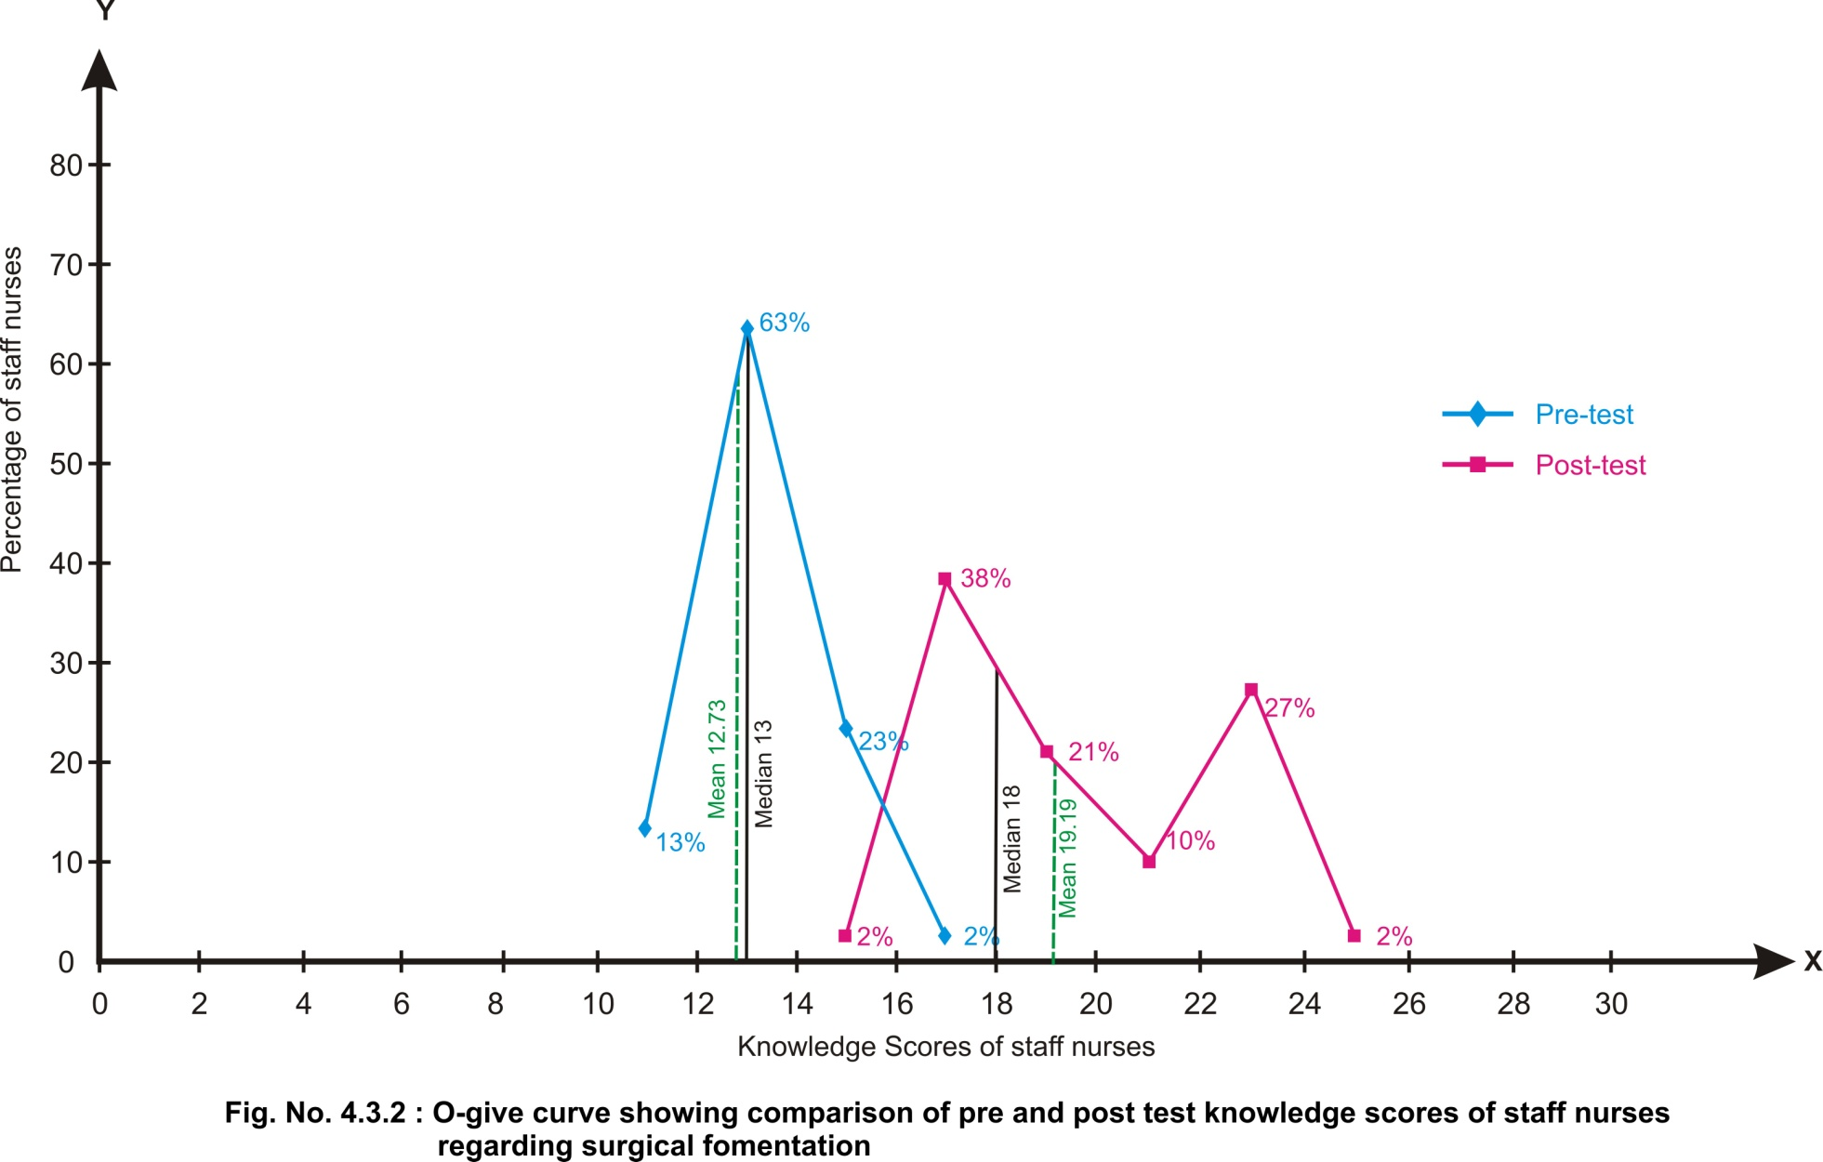
Line graph
Line graph showing the comparison of pre and post test knowledge scores show that the lowest score of pretest falls between 10-12 obtained by 13% of the nurses whereas for the post test it was between 14-16 obtained by 2% 0f the nurses. Highest percentage (63%) of the nurses score range between 12-14 during the pretest whereas during the post test the highest percentage 38% of score ranged between 16-18.
The median plotted on the graph shows that during pretest mean and median scores were 12.73 and 13respectively. However during post test mean and median were 19.19 and 18 respectively. Thus it reveals the effectiveness of video assisted teaching module regarding surgical fomentation of diabetic foot patients.(fig.4.3.1)

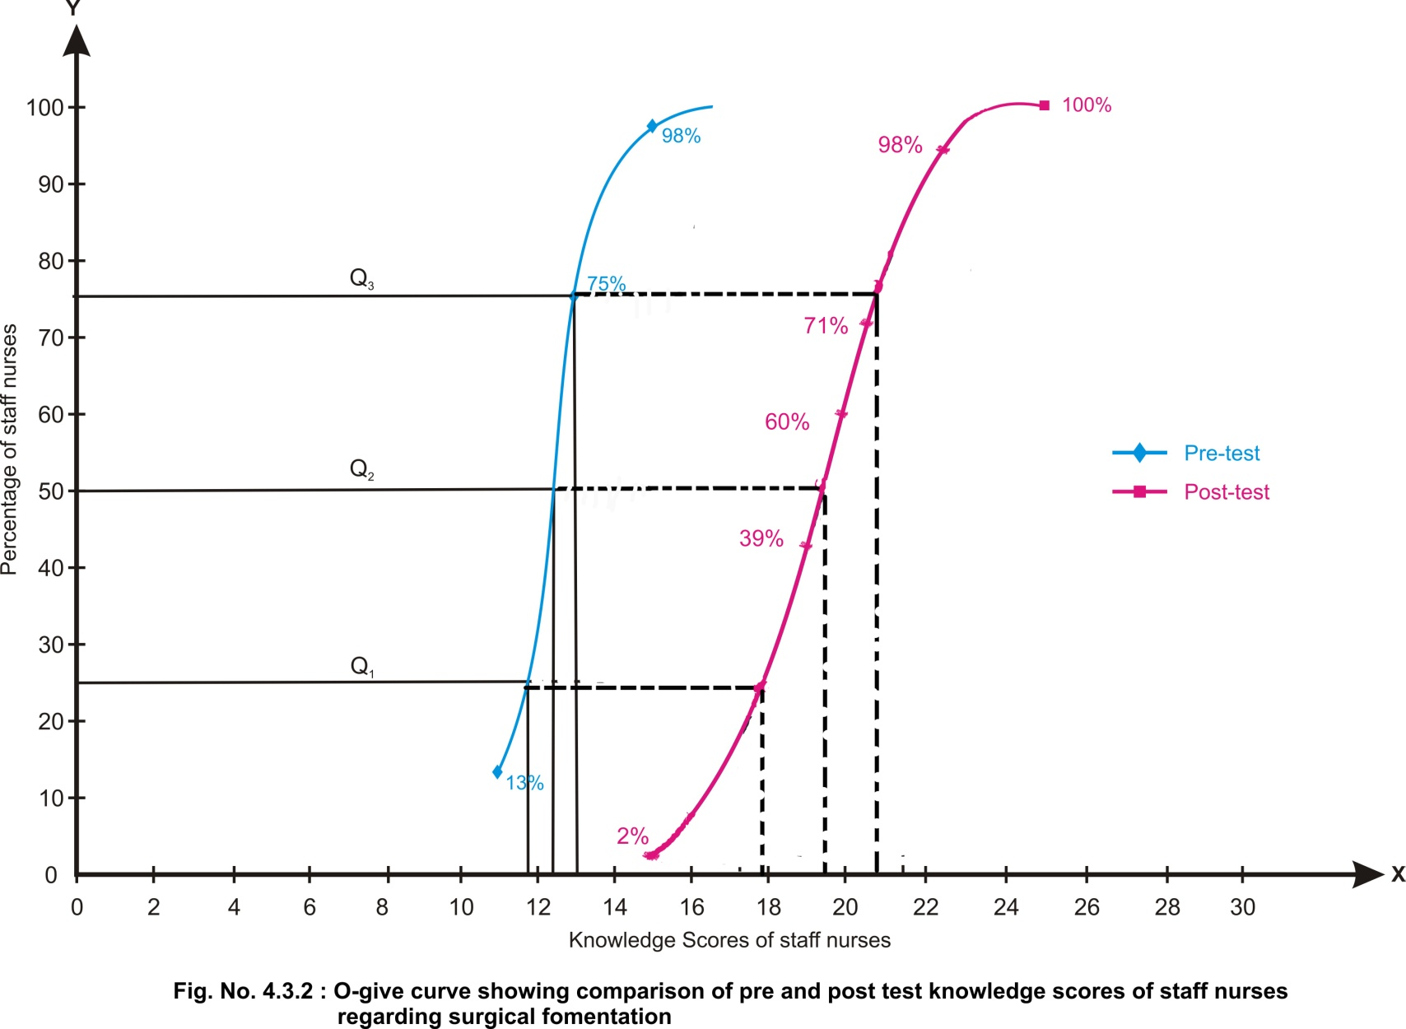

O-give curve
O-give curve showing the comparison of pre and post test cumulative percentage scores among staff nurses regarding surgical fomentation shows that the O give on post test score lies to the right of the pretest scores over the entire range.

Further distribution of percentile score reveals that in the pretest 25th percentile score was 11.5 whereas , it was 17.5 for the post test revealing a difference of 6, the 50th percentile score for pre test was 12.5 which was 19 for the post test revealing the difference of 6. The 75th percentile score for pretest was 13, which was 19 for the post test revealing a difference of 6. It seems that difference between pre and post test score were more or less similar 25th , 50th , and 75th percentile.

Fig.4.3.3: Bar diagram showing comparison of pre and post test on knowledge of staff nurses regarding surgical fomentation

Comparison of level of knowledge of pre and post test scores of the staff nurses regarding surgical fomentation shows that during pretest 35% of the staff nurses had poor level of knowledge on surgical fomentation, whereas 64.5% of the staff nurses had average level of knowledge. Further , during post test 45.8% of staff nurses had good knowledge level and 2% of staff nurses had excellent level of knowledge.

Hence, it can be interpreted that VATM was effective as the level of the staff nurses regarding surgical fomentation (fig.4.3.3)

Table No 4.3.2: Item wise comparison of pre and post test scores for correct response for the area of “Diabetic foot “regarding knowledge on practice on surgical fomentation of patients with diabetic foot among staff nurses
Items | Correct responses |  | Effectiveness of VATM  (E = Y – X)
Items | Pre test X (%) | Post test Y (%) | Effectiveness of VATM  (E = Y – X)
Diabetes mellitus is a disease condition characterized by increased blood glucose level | 46 | 69 | 23
The factor which is not related to diabetic foot is increased blood circulation to the legs. | 40 | 46 | 6
Delayed wound healing is caused by increased blood glucose. | 44 | 69 | 25
Chronic foot ulcerations in diabetic patients may lead to osteomyelitis and gangrene. | 29 | 58 | 29
The end result of diabetic foot may be amputation of feet. | 48 | 67 | 19
The preventive measure for formation of smooth corns or calluses is by using pumice stone. | 23 | 50 | 27
Nurses should prevent infection of diabetic foot by following strict aseptic technique while caring foot | 23 | 71 | 48

Item wise comparison of pre and post test scores for correct response for the area “diabetic foot” shows that during post test, the highest percentage(71%) of staff nurses responded correctly of the item “Nurses should prevent infection of diabetic foot by following strict aseptic technique while caring foot” and the effectiveness was also highest (48%) because of pretest score 40%.However the lowest percentage (46%) of them responded correctly for the item” The factor which is not related to diabetic foot is increased blood circulation to the legs.” which also has the lowest effectiveness of only 6% because of pretest score 40%.However the effectiveness of other items varies from 19% to 29%. Hence it can be interpreted that the VATM was effective for the items regarding ‘diabetic foot”.(Tab no 4.3.2).

Table No 4.3.3: Item wise comparison of pre and post test scores for correct response for the area of “Surgical fomentation “regarding knowledge on practice on surgical fomentation of patients with diabetic foot among staff nurses
Items | Correct responses |  | Effectiveness of VATM  (E = Y – X)
Items | Pre test X (%) | Post test Y (%) | Effectiveness of VATM  (E = Y – X)
Surgical fomentation is application of moist heat over an open wound | 33 | 54 | 21
The purpose of surgical fomentation are all except reduce number of cells. | 38 | 64 | 26
The most common indication of Surgical fomentation is diabetic foot. | 40 | 71 | 31
The contra indications of surgical fomentation is all except ulceration | 46 | 69 | 23

Item wise comparison of pre and post test scores for correct response for the area “surgical fomentation” shows that the highest effectiveness (31%) is for the item “The most common indication of Surgical fomentation is diabetic foot” where as the lowest effectiveness 21% is for the item “Surgical fomentation is application of moist heat over an open wound”. Further the effectiveness was 26% and 23% for the items “The purpose of surgical fomentation are all except reduce number of cells” and “The contra indications of surgical fomentation is all except ulceration” respectively.

Hence it can be interpreted that the VATM was effective for the items regarding surgical fomentation.

Table No 4.3.4: Item wise comparison of pre and post test scores for correct response for the area of “Physiological effects and preliminary assessment “regarding knowledge on practice on surgical fomentation of patients with diabetic foot among staff nurses

Items | Correct responses |  | Effectiveness of VATM  (E = Y – X)
Items | Pre test X (%) | Post test Y (%) | Effectiveness of VATM  (E = Y – X)
The common physiological effects of surgical fomentation is all except delayed wound healing. | 46 | 69 | 23
The following are the preliminary assessment of surgical fomentation except do regular exercise. | 44 | 65 | 21
The temperature range of warm water to be used in surgical fomentation is 105⁰F-115^{0F.} | 35 | 69 | 34
General precaution not to be done before starting the procedure is do not check physicians order. | 46 | 71 | 25

Item wise comparison of pre and post test scores for correct response for the area “Physiological effects and preliminary assessment” shows that the highest effectiveness (34%) is for the item ‘The temperature range of warm water to be used in surgical fomentation is 105⁰F-115⁰F” with a post test response of 69% which shows the effectiveness of the VATM where as the lowest effectiveness (21%) is for the item “The following are the preliminary assessment of surgical fomentation except do regular exercise” which also had the lowest post test response. However the effectiveness for the other items were from 23% and 25%. Hence it can be interpreted that the VATM was effective for the items regarding “ physiological effects and preliminary assessment.

Table No 4.3.5: Item wise comparison of pre and post test scores for correct response for the area of “Articles required “regarding knowledge on practice on surgical fomentation of patients with diabetic foot among staff nurses

Items | Correct responses |  | Effectiveness of VATM  (E = Y – X)
Items | Pre test X (%) | Post test Y (%) | Effectiveness of VATM  (E = Y – X)
The solution which is used to do surgical fomentation is Boric acid 2%. | 60 | 71 | 11
The instrument used to remove excessive water from fomentation pad is wringer. | 33 | 46 | 13
The article helps to prevent burn injury of foot during surgical fomentation is | 33 | 48 | 15
The article which are not needed for surgical fomentation is Foleys catheter. | 48 | 79 | 31

Item wise comparison of pre and post test scores for correct response for the area “articles required” shows that the highest posttest score(79%) is for the item “ the article which are not needed for surgical fomentation is Foleys catheter”which also shows the highest effectiveness of 31%. Whereas the lowest post test score(46%) is for the item “The instrument used to remove excessive water from fomentation pad is wringer” revealing the effectiveness of 15%.However the lowest effectiveness 11% is for the item. ”The solution which is used to do surgical fomentation is Boric acid 2%.’’which might be due to the highest pretest response 60%.

Hence it can be interpreted that the VATM was effectiveness for all the items regarding articles required for surgical fomentation.

Table No 4.3.6: : Item wise comparison of pre and post test scores for correct response for the area of “Procedure “regarding knowledge on practice on surgical fomentation of patients with diabetic foot among staff nurses

Items | Correct responses |  | Effectiveness of VATM  (E = Y – X)
Items | Pre test X (%) | Post test Y (%) | Effectiveness of VATM  (E = Y – X)
The time interval at which the pads should be changed during surgical fomentation is 15-20 mts. | 56 | 65 | 9
Surgical fomentation to be done only after cleaning the wound. | 54 | 73 | 19
The nurse should follow these steps while doing procedure except monitor blood sugar level. | 44 | 54 | 10
The frequency of surgical fomentation to be done to the diabetic foot patient is until ulcer heels. | 40 | 46 | 6
During fomentation , heat can be retained by hot water bag. | 46 | 71 | 25

Item wise comparison of the pretest and posttest correct responses for the area ‘procedure’ shows that during post test , the highest percentage (73%) was for the item “Surgical fomentation to be done only after cleaning the wound” whereas the lowest post test response (46%) is for the item “The frequency of surgical fomentation to be done to the diabetic foot patient is until ulcer heels” which also had the lowest effectiveness(6%) which might be due to the poor understanding of the item. However the effectiveness of the other items varies from 9% to 19%.

Hence it can be interpreted that the VATM was effectiveness for the items regarding procedure of diabetic fomentation.(Fig No:4.3.5).

Table No 4.3.7: Item wise comparison of pre and post test scores for correct response for the area of “after care “regarding knowledge on practice on surgical fomentation of patients with diabetic foot among staff nurses

Items | Correct responses |  | Effectiveness of VATM  (E = Y – X)
Items | Pre test X (%) | Post test Y (%) | Effectiveness of VATM  (E = Y – X)
Nurse should inspect patient’s feet twice a day | 44 | 50 | 6
After fomentation, patient’s feet is dried by dry automatically | 40 | 54 | 14
The solution that can be applied if the skin became red after the procedure is thin layer of oil. | 50 | 79 | 29
Nurse can keep patient’s feet warm by wearing cotton sacks for legs | 42 | 71 | 29

Item wise comparison of the pretest and posttest correct responses for the area after care of surgical fermentation shows that the highest effectiveness(29%) is similar for the items “Nurse can keep patient’s feet warm by wearing cotton sacks for legs” and “The solution that can be applied if the skin became red after the procedure is thin layer of oil” revealing a post test response of 71% and 79% respectively. However lowest effectiveness (6%) is for the item “Nurse should inspect patient’s feet twice a day” which might be due to the highest pre test response.

Hence it can be interpreted that the VATM was effective for the items of the area after care of surgical fomentation.
Table No 4.3.8: Item wise comparison of pre and post test scores for correct response for the area of “merits“ regarding knowledge on practice on surgical fomentation of patients with diabetic foot among staff nurses

Items | Correct responses |  | Effectiveness of VATM  (E = Y – X)
Items | Pre test X (%) | Post test Y (%) | Effectiveness of VATM  (E = Y – X)
Surgical fomentation is less expensive | 47 | 67 | 20
Surgical fomentation is effective in wound healing. | 55 | 77 | 22

Item wise comparison of the pretest and posttest correct responses for the area merits of surgical fomentation shows that the effectiveness was more or less similar(20% and 22%) for the items “Surgical fomentation is less expensive” and “Surgical fomentation is effective in wound healing” respectively.

Hence it can be interpreted that the VATM was effective for the items regarding the merits of surgical fomentation.

Section-IV
Comparison of the effectiveness of Video assisted teaching module with demographic variables of staff nurses regarding Surgical fomentation

Table No 4.4.1: Comparison of pre and post test regarding knowledge on practice on surgical fomentation of patients with diabetic foot among staff nurses with according to their age.
Age | No | Pre test scores |  |  | Post test scores |  |  | Difference in mean %
Age | No | Mean | SD | Mean % | Mean | SD | Mean % | Difference in mean %
21-25 yrs | 32 | 12.91 | 1.25 | 43 | 19.31 | 2.86 | 64 | 21
26-30 yrs | 12 | 12.33 | 0.98 | 41 | 18.92 | 2.87 | 63 | 22
31-35 yrs | - | - | - | - | - | - | - | -
>36 yrs | 4 | 12.5 | 1.73 | 42 | 19 | 2.31 | 63 | 21
Overall | 48 | 12.73 | 1.23 | 42 | 19.19 | 2.77 | 64 | 22

Comparison of pre and post test mean, SD and mean percentage with regard to age of the staff nurses shows that during post test the highest mean score (19.31±2.86) which is 64% of the total score was for the staff nurses in the age group of 21-25 years with effectiveness 21% more or less similar mean score(18.92±2.87 and 19±2.31) which is 63% was obtained by the staff nurses in the age group of 26-30years and above 36 years revealing an effectiveness of 22% and 21 % respectively. It reveals that the VATM was effective for all the age group. (Tab No;4.4.1)
Table No 4.4.2: Comparison of pre and post test regarding knowledge on practice on surgical fomentation of patients with diabetic foot among staff nurses with according to their gender .

Gender | No | Pre test scores |  |  | Post test scores |  |  | Difference in mean %
Gender | No | Mean | SD | Mean % | Mean | SD | Mean % | Difference in mean %
Male | 18 | 12.67 | 1.24 | 42 | 18.78 | 2.39 | 63 | 21
Female | 30 | 12.77 | 1.25 | 43 | 19.43 | 2.99 | 65 | 22
Overall | 48 | 12.73 | 1.23 | 42 | 19.19 | 2.77 | 64 | 22

Comparison of pre and post test mean, SD and mean percentage with regard to sex of the staff nurses shows that during post test score was more or less similar for both the groups(18.78±2.39 and 19.43±2.99) which were 63% and 65% respectively and the difference in mean was also more or less similar (21% and 22%). It reveals that the VATM was effective for the both gender respectively.(Tab No: 4.4.2).

Table No 4.4.3: Comparison of pre and post test regarding knowledge on practice on surgical fomentation of patients with diabetic foot among staff nurses with according to their educational status.

Educational status | No | Pre test scores |  |  | Post test scores |  |  | Difference in mean %
Educational status | No | Mean | SD | Mean % | Mean | SD | Mean % | Difference in mean %
Diploma | 14 | 12.86 | 0.66 | 43 | 18.79 | 2.67 | 63 | 20
B.sc | 29 | 12.59 | 1.48 | 42 | 19.14 | 2.86 | 64 | 22
P.BSc | 5 | 13.2 | 0.84 | 44 | 20.6 | 2.61 | 69 | 25
Overall | 48 | 12.73 | 1.23 | 42 | 19.19 | 2.77 | 64 | 22

Comparison of pre and post test mean, SD and mean percentage with regard to their educational status of the staff nurses shows that the highest post test score(20.6±2.61) which is 69% was obtained by the nurses who completed PcBSC which also had the highest effectiveness(25%) whereas the lowest post test score(18.79±2.67) which is 63% was obtained by the nurses who completed diploma nursing which also had the lowest effectiveness (20%).further the effectiveness was 22% for the staff nurses who had completed BSc nursing. (Tab No:4.4.3)

Table No 4.4.4: Comparison of pre and post test regarding knowledge on practice on surgical fomentation of patients with diabetic foot among staff nurses with according to their department where working .

Department where working | No | Pre test scores |  |  | Post test scores |  |  | Difference in mean %
Department where working | No | Mean | SD | Mean % | Mean | SD | Mean % | Difference in mean %
Medical ward | 21 | 12.95 | 1.35 | 43 | 19.67 | 2.92 | 66 | 23
Surgical ward | 14 | 12.57 | 1.02 | 42 | 19.93 | 2.95 | 66 | 24
ICU | 9 | 12.11 | 1.27 | 40 | 17.89 | 1.76 | 60 | 20
Others | 4 | 13.5 | 0.58 | 45 | 17 | 1.41 | 57 | 12
Overall | 48 | 12.73 | 1.23 | 42 | 19.19 | 2.77 | 64 | 22

Comparison of pre and post test mean, SD and mean percentage with regard to their area of working shows that during post test the highest mean score(19.67±2.92 and 19.93±2.95) which is 66% is obtained by the staff nurses working in the medical and surgical wards with similar highest effectiveness ( 23% and 24% respectively), this reveals that the VATM was more or less effective for all nurses irrespectively whereas the lowest post test mean score (17±1.41) which is 57% was for the staff nurses who were working in the other areas which also had the lowest effectiveness. However the effectiveness was 20% for the staff nurses who were working in the ICU. This reveals that the VATM was more or less effective for all nurses irrespective of their area of working.( Table No: 4.3.11)

Table No 4.4.5: Comparison of pre and post test regarding knowledge on practice on surgical fomentation of patients with diabetic foot among staff nurses with according to their in service education .

In-service education | No | Pre test scores |  |  | Post test scores |  |  | Difference in mean %
In-service education | No | Mean | SD | Mean % | Mean | SD | Mean % | Difference in mean %
Yes | 4 | 13.5 | 0.58 | 45 | 18 | 2.16 | 60 | 15
No | 44 | 12.68 | 1.25 | 42 | 19.29 | 2.82 | 64 | 22
Overall | 48 | 12.73 | 1.23 | 42 | 19.19 | 2.77 | 64 | 22

Comparison of pre and post test mean, SD and mean percentage with regard to attended in service education of staff nurses shows that the highest post test mean score(19.29±2.82) which is 64% was obtained by the staff nurses who had not attended any inservice education which also had the highest effectiveness (22%) whereas the lowest effectiveness(15%) was for the staff nurses who had attended inservice education regarding surgical fomentation. Hence it reveals that VATM was effective for the nurses who have attended and not attended inservice education program irrespectively.( Fig No:4.4.5)

Table No 4.4.6: Comparison of pre and post test regarding knowledge on practice on surgical fomentation of patients with diabetic foot among staff nurses with according to their in service education (if yes ) .

In-service education  (if yes) | No | Pre test scores |  |  | Post test scores |  |  | Difference in mean %
In-service education  (if yes) | No | Mean | SD | Mean % | Mean | SD | Mean % | Difference in mean %
1 | 3 | 13.33 | 0.58 | 44 | 18 | 2.65 | 60 | 16
2 | 1 | 14 | - | 47 | 18 | - | 60 | 13
Overall | 4 | 13.5 | 0.58 | 45 | 18 | 2.16 | 60 | 15

Comparison of pretest and post test mean percentage with regard to number of inservice programme attended shows that during post test, the mean score was similar for the no. of in-service education attended (18±2.65 and 47± ) which are 60% and the difference in mean percentage were also more or less similar 16% and 13% respectively. It reveals that VATM was effective for the nurses irrespective of the number of inservice programs attended.

Section – V
Testing of hypothesis
H₁ : There is no significant difference between pre-test and post-test knowledge scores of staff nurses regarding surgical fomentation
H₂ : There is no significant association between post test knowledge scores and selected demographic variables.

Table No 4.5.1: Paired ‘t’ test for pre and posttest regarding knowledge on practice on surgical fomentation of patients with diabetic foot among staff nurses
Sl. No. | Area | ‘t’ value | p-value | Level of significance
1 | Diabetic foot | 12.61 | 0.000 | Highly significant
2 | Surgical fomentation | 7.97 | 0.000 | Highly significant
3 | Physiological effects and preliminary assessment | 8.198 | 0.000 | Highly significant
4 | Articles required | 6.623 | 0.000 | Highly significant
5 | Procedure | 7.473 | 0.000 | Highly significant
6 | After care | 8.032 | 0.000 | Highly significant
7 | Merits | 5.226 | 0.000 | Highly significant
8 | Overall | 17.893 | 0.000 | Highly significant

(df= 47 table value = 3.496 ,p<0.001 highly significant )

Paired ‘t’ test was calculated to analyze the difference in overall and area wise pre-test and post test knowledge scores of staff nurses regarding knowledge on practice on surgical fomentation of patients with diabetic foot shows that highly significant difference was found between the area wise score values of pre test and post test. Hence, the states research hypothesis is rejected and statistical hypothesis is accepted(P<0.001). thus the difference in mean score values of pre test and post test were true difference not by chance.( table No: 4.5.1).

TableNo-4.5.2: Association between post test regarding knowledge among staff nurses with selected demographic data.

Sl. No | Demographic variables | Df | Table value | χ² value | Level of significance
 | Age | 2 | 5.99 | 0.0417 | Not significant
 | Gender | 1 | 3.84 | 0.05 | Not Significant
 | Educational status | 2 | 5.99 | 2.316 | Not significant
 | Department where working | 3 | 7.81 | 4.893 | Not Significant
 | In service education | 1 | 3.84 | 0.918 | Not significant
 | In service education (if yes) | 1 | 3.84 | 0.444 | Not significant
(P>0.05 = not significant)

Chi-square was calculated to find out the association between the post test and demographic variables of the staff nurses finding reveals that there was not significant association was found between knowledge scores of the staff nurses in post test when compared to the age, sex , educational status, department where working, inservice education and inservice education attended which shows significant relationship(P.0.05). hence it can be interpreted that the difference in mean score value related to the above mentioned demographic variables were not true difference but only by chance and null hypothesis was accepted.
Hence it is interpreted that the VATM was more effective for all the staff nurses irrespective of their demographic variables.(Tab No:4.5.2)

Summary:
This chapter dealt with analysis and interpretation of data collected to evaluate the effectiveness of video assisted teaching module regarding the surgical fomentation on diabetic foot patients. Findings revealed that the pretest knowledge mean score was 12.73 which is 42.4% of the total score whereas during the post test the total mean score was19.19 which is 63.9% of the total score, which reveals that the video assisted teaching module was effective for all the staff nurses regarding the surgical fomentation of patients with diabetic foot.

DISCUSSION, SUMMARY, CONCLUSIONS, IMPLICATIONS AND RECOMMENDATIONS.
A Pre experimental study where pre and post test without control group design and experimental approach was undertaken in Vinayaka Mission’s Kirupananda Variyar Medical College Hospital, Salem from 15.09.10 to 29.29.11. The data were collected by using closed ended questionnaire from 48 staff nurses by purposive sampling technique to assess their knowledge on practice on surgical fomentation of diabetic foot patients. The collected data were analyzed by using descriptive and inferential statistics and presented in chapter IV.
Discussion
This chapter deals with the discussion of the findings of chapter IV based on the objectives of the study. They are discussed under the following headings.
- Description of the characteristics of staff nurses.
- Assessment of knowledge of the staff nurses prior to the implementation of video assisted teaching module.
- Assessment of the effectiveness of video assisted teaching module on knowledge of the staff nurses regarding surgical fomentation of diabetic foot patients after distribution of video assisted teaching module.
- Area wise comparison of mean, SD and mean percentage of pre and posttest KS of staff nurses regarding surgical fomentation of diabetic foot patients .
- Line graph comparison of pretest and posttest KS of staff nurses regarding surgical fomentation of diabetic foot patients .
- O- give comparison of pretest and posttest KS of staff nurses regarding surgical fomentation of diabetic foot patients .
- Comparison of level of knowledge of pre and post test knowledge scores of staff nurses regarding surgical fomentation of diabetic foot patients.
- Item wise comparison of pre and posttest knowledge scores of the staff nurses regarding surgical fomentation of diabetic foot patients.
- Comparison of the effectiveness of self instructional module with demographic variables of the staff nurses regarding surgical fomentation of diabetic foot patients.
- Testing hypotheses
Section I
Distribution of staff nurses according to their age group depicts that highest percentage (67%) of staff nurses were in the age group of 21-25 years and lowest percentage (8%) were in the age group of 41-50 years. (Fig No: 4.1.1).This was supported by the study finding of Sumitra R.S .(2007), who also reported that most of the staff nurses (58.76%) were in the age group of 21-25 years.
Distribution of staff nurses according to their sex depicts that most of the staff nurses(63%) were female and 38% were males. (Fig No:4.1.2).This was more or less similar to the findings of Kedari R.(2007) who reported that most of the staff nurses (68%) were females.
Distribution of staff nurses according to their educational status depicts that the highest percentage(61%) of staff nurses had BSc nursing degree and lowest percentage (10%) of staff nurses had post basic BSc nursing degree.(Fig No: 4.1.3).It is contradictory to the findings of Augustine R.V .(2007) who observed in her study almost majority of (72%) staff nurses were diploma holders.
Distribution of staff nurses according to their area of working shows that the highest percentage (44%) of staff nurses are working in the medical ward further the lowest percentage (8%) of staff nurses are working in the other areas such as O.T and O.P.Ds.(Fig No:4.1.3).This finding was supported with the study done by Susan V.L (2007) who also stated that the highest percentage of the staff nurses (47% ) were working in medical ward.
Distribution of staff nurses according to their previous source of information shows that majority (92%) of the nurses didn’t attend the inservice program attended whereas lowest percentage (8%) of nurses who have attended.(Fig No: 4.1.4).This was supported by George R.(2007), who also reported that only 14% of study participants attended in-service program regarding diabetic care
Distribution of staff nurses according to their previous source of information shows that majority (75%) of the nurses attended the inservice program only one time whereas lowest percentage(25%) of nurses attended two times.(Fig No; 4.1.4).This finding was consistent with the finding of Jayram P.(2007) who also found that almost all (82%) staff nurses had attended only a single inservice education program.
Section II
Area wise distribution of mean, SD and mean percentage of pre test scores regarding knowledge on practice on surgical fomentation of patients with diabetic foot among staff nurses shows that the highest mean score(1±0.68) which is 51% of the total score was obtained in the area of “ procedure” of surgical fomentation whereas lowest mean scores (2.52±0.74) was 36% obtained in the area “diabetic foot”.
During pre test overall mean score (12.73±1.23) was 42% reveals that the staff nurses understudy had below average knowledge regarding the surgical fomentation on patients with diabetic foot.(table No:4.2.1).
Section III
Area wise distribution of mean, SD and mean percentage of pre test and post test knowledge scores of staff nurses regarding knowledge on practice on surgical fomentation of patient with diabetic foot among staff nurses that shows that the highest post test mean score( 1.44±0.501) which is 72% was obtained in the area of “merits” of diabetic fermentation with an effectiveness of 22%. The highest effectiveness (26%) was obtained in the area “surgical fomentation” which shows the effectiveness of the VATM further the lowest effectiveness(15%) is for the area procedure which might be due to less opportunity for practice of staff nurses regarding the area. However the effectiveness for all other areas varies from 17% to 26%.
Comparison of overall mean score , SD, and mean percentage of pre and post test knowledge scores reveals that mean score (19.19±2.77) which is 64% revealing the effectiveness of VATM.(Tab no 4.3.1).
Line graph
Line graph showing the comparison of pre and post test knowledge scores show that the lowest score of pretest falls between 10-12 obtained by 13% of the nurses whereas for the post test it was between 14-16 obtained by 2% 0f the nurses. Highest percentage (63%) of the nurses score range between 12-14 during the pretest whereas during the post test the highest percentage 38% of score ranged between 16-18.
Further the mean and median plotted on the graph shows that mean and median scores were 12.73 and 13respectively. However during post test mean and median were 19.19 and 18 respectively. Thus it reveals the effectiveness of video assisted teaching module regarding surgical fomentation of diabetic foot patients.(Fig.No;4.3.1)

O- give curve
O-give curve showing the comparison of pre and post test cumulative percentage scores among staff nurses regarding surgical fomentation shows that the O give on post test score lies to the right of the pretest scores over the entire range.
In the pretest 25th percentile score was 11.5 whereas , it was 17 for the post test revealing a difference of 5.5, the 50th percentile score for pre test was 12.5 which was 17.5 for the post test revealing the difference of 5. The 75th percentile score for pretest was 13, which was 21 for the posttest revealing a difference of 8. It seems that difference between pre and past test score were more or less similar 25th , 50th , and 75th percentile.
Comparison of pre and post test on knowledge of staff nurses regarding surgical fomentation.
Comparison of level of knowledge of pre and post test scores of the staff nurses regarding surgical fomentation shows that during pretest less than 35% of the staff nurses had poor level of knowledge on Surgical fomentation, whereas 64.5% of the staff nurses had average level of knowledge. Further , during post test 45.8% of staff nurses had good knowledge level and 2% of staff nurses had excellent level of knowledge.
Item wise comparison of pre and post test knowledge scores of the staff nurses regarding the care of patients with lithium carbonate therapy
Diabetic foot
Out of seven items related to diabetic foot during pre test correct responses were less that 50% for all the items whereas during post test all the items scores above 50% except the item “The factor which is not related to diabetic foot is increased blood circulation to the legs”.
Surgical fomentation
Out of three questions related to the surgical fomentation , during pre test correct responses were less then 50% for all the items whereas during post test all the items scored above 50%. However the effectiveness varies from 21% to 31%.
Knowledge on practice on surgical fomentation
Out of four items related to knowledge on practice of surgical fomentation , during pre test correct responses were less than 50% for all the items whereas during post test all the items scored above 50 percentage. The effectiveness varies from 21% to 34%.
Articles required
Out of four items related to articles required , during pre test correct responses were less than 50% for all the items except the item” The solution which is used to do surgical fomentation is Boric acid 2%.”(60%) whereas during post test two items scored above 50 % and the other two items scored below 50%.however the effectiveness varies from 11% to 31%.
Procedure
Out of 5 items related to procedure, during pre test correct responses were less than 50% for all the items except the item “The time interval at which the pads should be changed during surgical fomentation is 15-20 mts” and Surgical fomentation to be done only after cleaning the wound” (56% and 54%) whereas during post test all the items scores above 50% except the item “The frequency of surgical fomentation to be done to the diabetic foot patient is until ulcer heels”(46%). However the effectiveness varies from 6% to 25%.
After care
Out of 4 items related to after care of surgical fomentation, during pre test all the items scored less than 50% except for the item “The solution that can be applied if the skin became red after the procedure is thin layer of oil”(50%) whereas during post test all the items scores above 50%. However the effectiveness varies from 6% to 29%.
Merits
Out of two items related to merits of surgical fomentation , during pre test one item scored less than 50 % and the other item scored below 50% whereas during post test all the items scored above 50%. However the effectiveness varies from 20% to 22%.
Section IV
Comparison of pre and post test regarding knowledge on practice on surgical fomentation of patients with diabetic foot among staff nurses with according to their demographic variables
During post test the highest mean score (19.31±2.86) which is 64% of the total score was for the staff nurses in the age group of 21-25 years with effectiveness 21%.similar mean score(18.92±2.87 and 19±2.31) which is 63% was obtained by the staff nurses in the age group of 26-30years and above 36 years revealing an effectiveness of 22% and 21 % respectively(Tab No:4.4.1).It is consistent to the study findings of Luckmann J. (2006), who reported that knowledge status of the staff nurses after implementation of the education program on surgical fomentation had more effectiveness on age group of 26-30 years .
During post test score was more or less similar for both the groups(18.78±2.39 and 19.43±2.99) which were 63% and 65% respectively and the difference in mean was also more or less similar. (21% and 22%) (Tab No: 4.4.2).The present finding is consistent with the study of Godse T. R (2005) who stated that implementation of VATM was effective to all nurses irrespective of their gender.
Highest post test score(20.6±2.61) which is 69% was obtained by the nurses who completed PcBSC which also had the highest effectiveness(25%) whereas the lowest post test score(18.79±2.67) which is 63% was obtained by the nurses who completed diploma nursing which also had the lowest effectiveness (20%).(TabNo:4.4.3.). It is consistent with the report of Kshitiji. B (2007) who stated that as the education increases , level increases.
During post test the highest mean score(19.67±2.92 and 19.93±2.95) which is 66% is obtained by the staff nurses working in the medical and surgical wards with more or less similar highest effectiveness ( 23% and 24% respectively), this reveals that the VATM was more or less effective for all nurses irrespectively whereas the lowest post test mean score (17±1.41) which is 57% was for the staff nurses who were working in the other areas which also had the lowest effectiveness.(Tab No:4.4.4) It was contradictory to the findings of Kalyan B. (2006) who observed that staff nurses working in the intensive care units are having more knowledge.
Highest post test mean score(19.29±2.82) which is 64% was obtained by the staff nurses who had not attended any inservice education which also had the highest effectiveness (22%) whereas the lowest effectiveness(15%) was for the staff nurses who had attended inservice education regarding surgical fomentation.(Fig No:4.4.5). eliza (2007) conducted a study on knowledge of staff nurse regarding diabetic foot care shows that the knowledge was irrespective of their attended in-service education.
Comparison of pretest and post test mean percentage with regard to number of in service programme attended shows that during post test, the mean score was similar for the no. of in-service education attended (18±2.65 and 47± ) which are 60% and the difference in mean percentage were also more or less similar 16% and 13% respectively(Fig No: 4.4.6)
Section -V
Hypothesis testing
Highly significant difference was found between the area wise score values of pre test and post test. Hence, the states research hypothesis is rejected and statistical hypothesis is accepted(P<0.001) indicating effectiveness of SIM.
There was not significant association was found between knowledge scores of the staff nurses in post test when compared to the age, sex , educational status, department where working, inservice education and inservice education attended which shows significant relationship(P.0.05).
Summary
A pre experimental study was conducted on 48 staff nurses to assess the effectiveness of VATM regarding knowledge on practice on surgical fomentation among staff nurses in Vinayaka mission kirupananda variyar medical college, salem, tamil naidu. Data collection were collected from 1-10-2011 to 15-10-2011 through closed interview schedule. Collected data were analyzed by using descriptive and inferential statistics.
Findings are summarized as follows
- The highest percentage(67%) of the staff nurses were in the age group of 21-25 years, 61% were BSc nursing degree holders, 44% were working in the medical surgical wards and 92% of them did not attend any inservice program regarding surgical fomentation.
- Majority of staff nurses were females (63%) when compared to males(37%).
- Overall mean score (12.73±1.23) was 42% reveals that the staff nurses understudy had below average knowledge regarding the surgical fomentation on patients with diabetic foot.
- Overall pretest mean score was 12.73±1.23 which is 42%, whereas in post test the mean score was 19.19±2.77 which is 64% revealing the effectiveness of VATM which is 22%.
- Highest percentage score during post test 52% had average knowledge and 45.8% had good knowledge.
- Line graph shows during pre test highest percentage( 63%) of the nurses score between 12-14 whereas during post test highest percentage (38%) of the staff nurses scored between 16-18.
- O-give curve shows that the 25th , 50th and 75th percentile were higher than the pre test scores.
Comparison of post test knowledge score related to the effectiveness of VATM with demographic variables show that
- Highest effectiveness(22%) is for the staff nurses in the age group 26-30years.
- Effectiveness of VATM was more or less similar for the both male and female(21 and 22 respectively) staff nurses.
- Effectiveness of the VATM was highest ( 25%) for the PBSc nurses and lowest for BSc nursing degree holders.
- Effectiveness of the VATM was highest(24%) for the staff nurses working in the medical surgical wards.
- Effectiveness of the VATM was highest (22%) for the staff nurses who were not attended in any in-service education program.
- Effectiveness of the VATM was highest(16%) for the staff nurses who attended the in-service education program for a single time.
- Highly significant difference was found between the area wise score values of the pre test ,post test and overall.
- There was no significant association between knowledge of staff nurses in the post test when compared with the age, sex, area of working, educational status, in-service education attended and number of in-service education attended.
Conclusion
The present study assessed the effectiveness on knowledge on practice of staff nurses regarding surgical fomentation of diabetic foot patients through video assisted teaching module.
The findings of this study revealed that there is significant difference in all the areas regarding surgical fomentation of diabetic foot patients.
In service education given using VATM after post test played an important role to enhance the knowledge on practice of staff nurses on surgical fomentation.Based on the findings it can be concluded that, after implementing in service education to the staff nurses a vast improvement has been observed in their knowledge on surgical fomentation. Also it was found that there is no significant relationship between the post test knowledge scores when compared with the demographic variables of staff nurses.
In this study it is evident that, the awareness of staff nurses can be promoted through in service education to increase knowledge and perception of staff nurses regarding surgical fomentation regarding surgical fomentation of diabetic foot patients.
Overall the study findings reveals that the in service education implemented by the investigator on surgical fomentation for staff nurses of Vinayaka Mission’s Kirupananda Variyar Medical College Hospital, Salem has a good effect.
Implications
Nursing service
- The content of the video assisted teaching module will help the nursing professionals working in hospitals for reinforcing the knowledge on surgical fomentation.
- The findings will help the nursing personnel to estimate the effectiveness of video assisted teaching module.
Nursing education
- The nurse educators can use the VATM to teach the student nurses about surgical fomentation of diabetic foot patients.
- Nurse educator can use the VATM to educate the nurses to improve the knowledge regarding surgical fomentation.
Nursing research
- Finding of the study can be utilized for conducting research using large sample.
- Further research can be done to assess the staff nurses knowledge and skill on surgical fomentation.
- A study can be done to determine the staff nurses level of knowledge regarding surgical fomentation.
Recommendations
- A large scale study can be done for replication to standardize the VATM on surgical fomentation.
- Similar study can be conducted with an experimental research approach having a control group.
- A comparative study can be carried out to generalize the findings.
- A similar study can be conducted by using VATM for educating the staff nurses in government hospitals to improve the knowledge regarding surgical fomentation.

Summary

This chapter has with the summary of the study , major findings and conclusions, implications of the study in nursing field , education and recommendation for future.
BIBLIOGRAPHY
- Armstrong DG and Lavery LA, (2005) “ Diabetic foot ulcers “. Am Fam Physician, Mar57:1325-32, 1337-38.
- Afridi MA and Khan MN.,(2003)” Role of health education in the management of diabetes mellitus”. Cardiovasc Med, 4 Suppl 6:S3-10
- Armstrong DG.,et al. (2000) “Diabetic foot disorders: a clinical practice guideline” J foot Ankle Surg,39 ( 5 Suppl):S1-60.
- Ambrosh A, Lehnert H, Lobmann R., (2007) “Microbiological aspects and antibiotic therapy of diabetic foot infections” Clin podiatry, Aug: 1(2):343-41
- Banks AS. Mc Glamry ED., (2006) “Chariot Foot”. J Am podiatry Med Assoc. May 79:213-35
- Birrer RB and Rauscher H., (2007) “ office podiatry” A Fam Physician,Mar25:141-7.
- Bayo J., et al.(2003) “Diabetes conrol wiyh physical activity and exercise”, Nutr Clin care, May-Sep :6(2): 89-96
- Barbare K, Timy Jeance C, Scherer Nancy E., (2001) “ Text book of Medical Surgical nursing”. Lippincott 7th edition, P 827, 840.
- Carrington AL., et al (2001) “ A foot care program for diabetic unilateral lower limb ambutes”. Diabetes care. Feb 24:216-21.
- C S Cockran., (2005) “ The Epidemiology of diabetes mellitus in the Asia-pacific region”. Hong Kong Medical J., 6(1) 43-52
- Donohoe ME., et al. (2003) “ Improving foot care for people with diabetes mellitus a randomised controlled trial of an integrated care approach”. Diabetes Med, Aug 17: 581-7.
- Donna D., et al (2007) “ Textbook of Mediacal Surgical Nursing” ,W.B Saunders company, 2nd edition : P 1857, 1866, 1897.
- Eneroth M, Larsson J and A Pelquist J., (2008) “Deep foot infections in patients with diabetes and foot ulcers: an entity with different characteristics, treatments and prognosis”. Diabetes Res Chin Pract, Mar: 39(3):185-91.
- Frykberg RG.,(2005) “Management of neuropathy and foot problems in diabetic patients”. Diabetes metab, Dec : 29(6);619-27.
- Han Py., et al (2003) “Comorbidities associated with diabetic foot complications among Asian Americans in southern California”. Jam podiatry Med Assoc, Jan-Feb 93:37-41
- Kaurk, et al. (1998) “ Knowledge and self care practice of diabetes in a resettlement colony of Chandigarh Indian”. J Med Sci, Aug 52:341-7.
- Liukkonen. T.,et al. (2006) “Long term effective of one year of intensified podiatric activity on foot care knowledge and self care habits in patients with diabetes”. Diabetes Educ, Nov-Dec 24: 734-40
- Lopez Espula F., et al. (2006) “Diabetic foot a severe complication “. Radol Clin North Am, Nov:25-26:1095-1097
- Lewis Heitremper Dirkson., “Textbook of Medical Surgical Nursing “ Mosby publications 6th edition : P 1269-70.
- Luckman and Sorenson., (2004) “Textbook of Medical Surgical Nursing” W.B Saunders Company 2nd edition P 1546
- Lakshminarayan . S., et al. (1998) “An epidemiological study of the prevalence of diabetes in a rural population near Chennai-“. Novo Nordisk diabetes update, March 18-20.
- Meijer JW., et al. (2001) “ Evolution of a screening and prevention programme for diabetic foot complication”. Prostnet-orthot int, Aug 25:135-8.
- Petrasovicm., et al. (2008) “ Care of the diabetic foot”. Batisl lek listy, Oct 98:572-6.
- Priollet P, Letanoxm, Cormier Jm., (2004) “General principles of medical care of the diabetic foot”. J mal Vase, 18:24-9.
- Springett K and White R J., (2007) “Skin change in the foot and their treatment”. Nurse Dec:25-32.
- Simmons D., et al. (2010) “ Foot care among diabetic patients”. Med J, Mar 108:106-8.
- Smeltzer S.C and Bare B. G., (2007) “ Textbook of Medical Surgical Nursing “ Lippincott William , 10 th edition, P-1150.
- Vides H., et al. (2001) “Diabetes and social conditions “ . J Public Health , Mar11:60-4
- Tapp RJ., et al. (2002) “Foot complications in type 2 diabetes”. Med Pregl, Aug:55(7-2) 329-34.
- Thomas MB., et al. (2003) “The diabetic foot”. Am Physician, Nov 1:68(9):1767-73
- Ward JD., (1984) “The diabetic foot”. Wein Klin Wochenschlr . Jan96:17-20

Annuxure - I
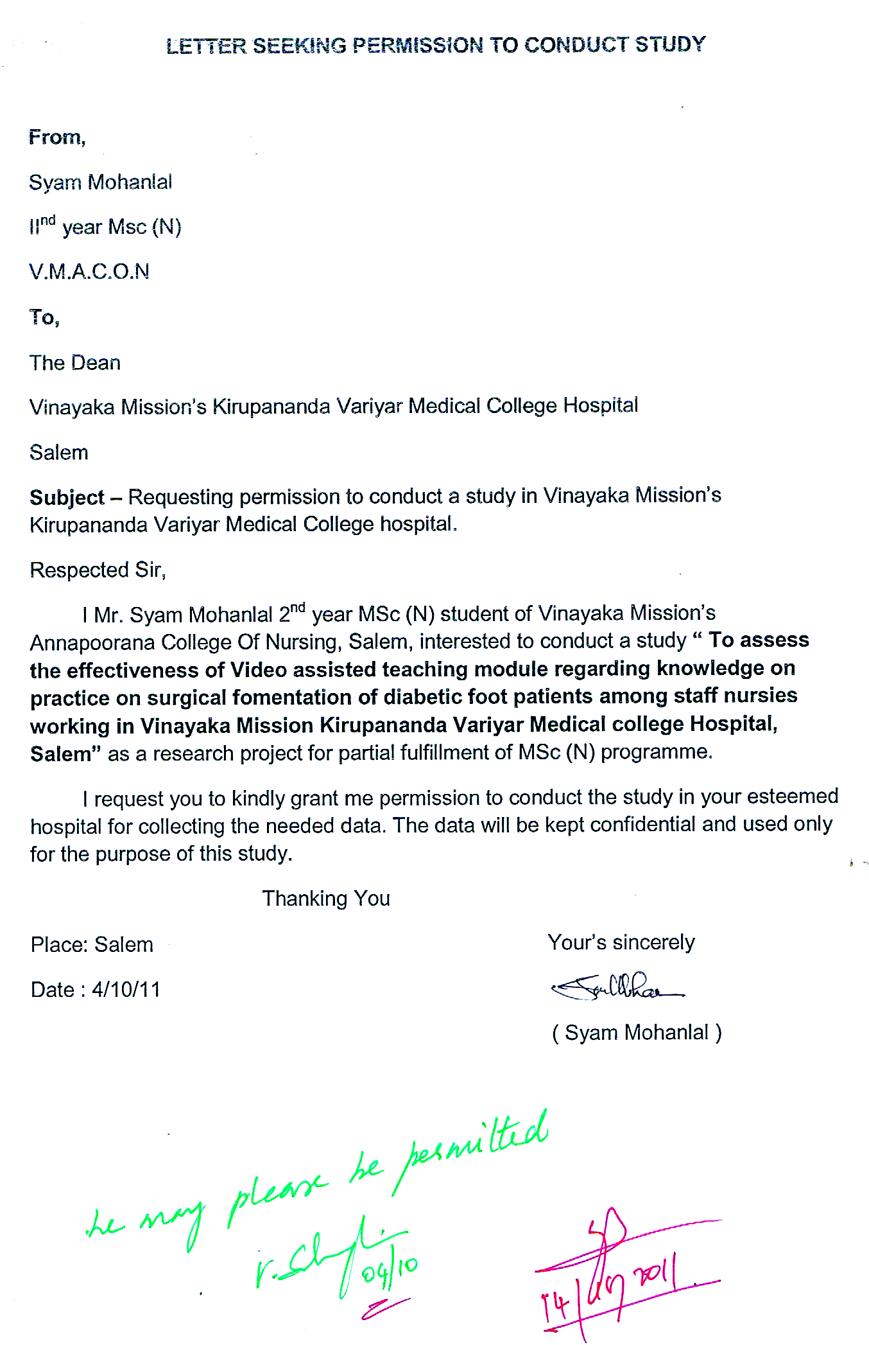
Annuxure - II
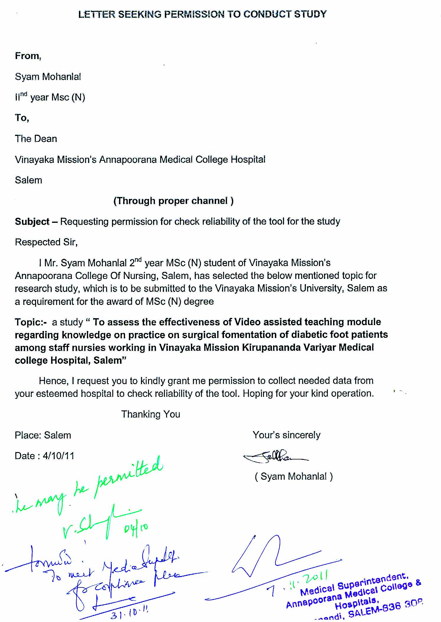
Annuxure - III Annuxure – IV

CERTIFICATE OF VALIDATION

This is to certify that the tools,
1. Video Assisted teaching Module
2. Closed Ended Questionnaire

Constructed by Mr.Syam Mohanlal, MSc (N),2nd year student of Vinayaka Mission’s Annapoorana College of Nursing, Salem, to be used in her study titled, , “Assess the effectiveness of video assisted teaching module regarding knowledge on practice on surgical fomentation of diabetic foot patients among staff nurses working in Vinayaka Mission Kirupananda Variyar Medical College Hospital , Salem,” has been validated by me.

Signature:

Name:

Designation:

Date:
OPINION OF EXPERTS REGARDING THE CLOSED ENDEED QUESTIONNAIRE
SECTION -A
Q.No | Appropriate | Not Appropriate | Suggestions
1.
2.
3.
4.
SECTION-B
Q.No | Appropriate | Not Appropriate | Suggestions
5.
6.
7.
8.
9.
10.
11.
12.
13.

14.
15.
16.
17.
18.
19.
20.
21.
22.
23.
24.
25.
26.
27.
28.
29.
30.
Annuxure - V
CLOSED ENDED QUESTIONNAIRE
Instructional to the participants
The questionnaire is to assess the knowledge on practice of staff nurses regarding surgical fomentation on diabetic patients. It has 2 sections. Section A and section B .Select the answer which is appropriate and place a tick mark on the answer . All the information provided will be kept confidential.
SECTION-A
Name:
- Age (in years).
    - 21-25 ( )
    - 26-30 ( )
    - 31-35 ( )
    - Above-36 ( ) 3

- Gender.
    - Male ( )
    - Female ( )

3. Educational status
i. Diploma ( )
ii. Bsc (N) ( )
iii. PBSc (N) ( )

4. Department where working
i. Medical ward ( )
ii. Surgical ward ( )
iii. ICU s ( )
iv. others ( )

5. Inservice educational programme attended on surgical fomentation for Diabetic foot patients
i . Yes ( )
ii. No ( )
a) if yes how many times
i. 1 ( )
ii. 2 ( )

SECTION-B
A) DIABETIC FOOT
1. Diabetes mellitus is a disease condition characterized by
i. Increased blood glucose level ( )
ii. Decreased blood glucose le ( )
iii. Increased fluid volume ( )
iv. Decreased fluid volume ( )

2. The factor which is not related to diabetic foot is
i. Loss of sensation ( )
ii. Decreased blood circulation ( )
iii. Increase the risk of infection ( )
iv. Increase blood circulation to the legs ( )

3 Delayed wound healing is caused by
i. Increased blood glucose ( )
ii. Increased blood supply ( )
iii. Increased insulin level ( )
iv. Decreased blood sugar level ( )

4. Chronic foot ulcerations in diabetic patients may lead to
i. Calluses and ulcerations ( )
ii. Neuropathy and nephropathy ( )
iii. Osteomyelitis and gangrene ( )
iv. Coronary artery diseases ( )
5 The end result of diabetic foot may be
i. Calluses formation ( )
ii. Amputation of feet ( )
iii. Thickness of feet ( )
iv. Edema and redness ( )

6. The preventive measure for formation of smooth corns or calluses is by using
i. Pumice stone ( )
ii. Soap and water ( )
iii. Cold water ( )
iv. Foot binder ( )

7. Nurses should prevent infection of diabetic foot by following
i. Good sponge bath technique ( )
ii. Strict aseptic technique while caring foot ( )
iii. Wearing mask while caring foot ( )
iv. Proper cleanliness of wards while caring foot ( )

B) SURGICAL FOMENTATION
8. Surgical fomentation is
i. Application of moist heat over an open wound ( )
ii. Application of medication over an open wound ( )
iii. Application of foot binder ( )
iv. Surgical repair of open wound ( )
9. The purpose of surgical fomentation are all except
i. To promote healing ( )
ii. To reduce pain and inflammation ( )
iii. To reduce swelling ( )
v. To reduce number of cells ( )

10. The most common indication of Surgical fomentation is
i. Diabetic foot ( )
ii. Burns ( )
iii. Psoariasis ( )
iv. Dermatitis ( )

11. The contra indications of surgical fomentation is all except
i. Impaired vital function and perception ( )
ii. Oedema associated with venous disease ( )
iii. High temperature and head ache ( )
iv. Ulceration ( )

C)PHYSIOLOGICAL EFFECTS AND PRELIMINARY ASSESSMENT
12. The common physiological effects of surgical fomentation is all except
i. Vasodilation ( )
ii. Hyperthermia ( )
iii. Increased muscle relaxation ( )
iv. Delayed wound healing ( )

13. The following are the preliminary assessment of surgical fomentation except
i. Check the available articles in patients unit ( )
ii. Check the physicians order ( )
iii. Assess the general condition of the patient ( )
iv. Do regular exercise ( )

14.The temperature range of warm water to be used in surgical fomentation is
i. 80 F-98 F ( )
ii. 105⁰ F-115⁰F ( )
iii. 120 F-135 F ( )
iv. 90 F-105 F ( )

15. The general precaution not to be done before starting the procedure is
i. Provide privacy and drape patient ( )
ii. Wash hands ( )
iii. Check the temperature of water after pouring ( )
iv. Do not check physicians order ( )

D) ARTICLES REQUIRED
16. The solution which is used to do surgical fomentation is
i. Magnesium sulphate ( )
ii. Boric acid 2% ( )
iii. Betadine solution ( )
iv. Hydrogen peroxide ( )
17. The instrument used to remove excessive water from fomentation pad is
i. Wringer ( )
ii. Thumb forceps ( )
iii. Transfer forceps ( )
iv. Sterile bin ( )

18. The article helps to prevent burn injury of foot during surgical fomentation is
i. Hot water bag ( )
ii. Lotion Thermometer ( )
iii. Wringer ( )
iv. Artery forceps ( )

19. The article which are not needed for surgical fomentation is
i. Fomentation pads ( )
ii. Big piece of cotton ( )
iii. Lotion thermometer ( )
iv. Foley’s catheter ( )

D) PROCEDURE
20. The time interval at which the pads hould be changed during surgical fomentation is
i. 15-20 mts ( )
ii. 10-15 mts ( )
iii. 30-55 mts ( )
iv..40-55 mts ( )
21. Surgical fomentation to be done only
i. On the old dressing ( )
ii. After cleaning the wound ( )
iii. After giving food ( )
iv. After arrival of physician ( )

22. The nurse should follow these steps while doing procedure except
i. Strict aseptic principles should be observed ( )
ii. All things which come in contact with wound
should be sterile ( )
iii. Care should be taken to prevent the burning of skin ( )
iv. Monitor blood sugar level ( )

23. The frequency of surgical fomentation to be done to the diabetic foot patient is
i. regular basis ( )
ii. until the ulcer heels ( )
iii. weekly ( )
iv. twice weekly ( )

24. During fomentation , heat can be retained by
i. Hot water bag ( )
ii. Cold application ( )
iii. Foot binder ( )
iv. Any other specify ( )
E) AFTER CARE
25. Nurse should inspect patient’s feet
i. once a day ( )
ii. twice a day ( )
iii. thrice a day ( )
iv. twice weekly ( )

26. After fomentation, patient’s feet is dried by
i. Towel ( )
ii. Heater ( )
iii. Dry automatically ( )
iv. Rough cloth ( )

27. The solution that can be applied if the skin became red after the procedure is
i. Thin layer of oil ( )
ii. Sulphonamide ( )
iii. Topical corticosteroids ( )
iv. Betadine solution ( )

28. Nurse can keep patient’s feet warm by
i. Wearing cotton sacks for legs ( )
ii. Advice to keep the foot in hot water ( )
iii. Advice to keep the leg near fire ( )
iv. Any other specify ( )
F) MERITS
29. Surgical fomentation is
i. more expensive ( )
ii. less expensive ( )
iii. depends on the type of wound ( )
iv. depends on the service offered by the nursing personnel ( )

30. Surgical fomentation is effective in
i. wound healing ( )
ii. preventing discharges ( )
iii. maintain blood glucose level ( )
iv. enhance the production of insulin ( )

Annuxure - VI
ANSWER KEY
Question number | Answer
1 | 1.1
2 | 2.4
3 | 3.1
4 | 4.3
5 | 5.2
6 | 6.1
7 | 7.2
8 | 8.1
9 | 9.4
10 | 10.1
11 | 11.4
12 | 12.4
13 | 13.4
14 | 14.2
15 | 15.4
16 | 16.2
17 | 17.1
18 | 18.2
19 | 19.4
20 | 20.1
21 | 21.2
22 | 22.4
23 | 23.2
24 | 24.1
25 | 25.2
26 | 26.3
27 | 27.1
28 | 28.1
29 | 29.2
30 | 30.1
Annuxure - VII
LIST OF EXPERTS
- Mrs. Nivedhitha MSc (N)
Assistant Professor
Government College of Nursing
Coimbatore.

- Mrs. Anitha MSc (N)
Professor
Sri Gokulam College of Nursing
Salem

- Mrs. Lavanya MSc (N)
Associate Professor
PPG College of Nursing
Salem.

- Mr. Mani MSc (N)
Biostatistician
V.M.A.C.O.N
Salem

ANNEXURE VIII
LESSON PLAN
VIDEO ASSISTED TEACHING MODULE FOR SURGICAL FOMENTATION OF DIABETIC FOOT PATIENTS.

Name of teacher : Syam Mohanlal
Topic : Surgical Fomentation
Group : Staff nurses in Vinayaka mission kirupananda variyar medical college hospital, Salem.
Duration : 20-30 minutes
Medium of Instruction : English
Method of teaching : Lecture cum demonstration
AV aids : VATM
Place : Vinayaka Mission Kirupananda Variyar Medical College Hospital, Salem.
General Objective : After completion of teaching module, the staff nurses will acquire knowledge about Surgical
Fomentation of diabetic foot patients and apply this in practice.
Give an introduction about Surgical fomentation  Define Diabetes Mellitus  Explain about Diabetic foot  Define Surgical Fomentation  Describe purposes of Surgical fomentation  List out Indication and Contra indication of Surgical Fomentation  Explain physiological effects of Surgical fomentation  Explain preliminary assessment of patient before doing Surgical fomentation  List out the articles needed for Surgical fomentation  Explain the procedure Surgical fomentation  Describe the aftercare of Surgical Fomentation  Describe the merits of Surgical fomentation | INTRODUCTION  Diabetes Mellitus is one of the most common non communicable diseases globally. It is the fourth or fifth leading cause of death in most developed countries and there is substantial incidence that it is epidemic in many developing and newly industrialized nations thus , posing a serious threat to be met within the 21st century. Foot ulceration and infection are serious foot complications of diabetic mellitus that can lead to gangrene and lower limb ambutation. Major nursing care often applied to diabetic foot infections are Surgical fomentation  DIABETES MELLITUS  Diabetes Mellitus is the disease condition in which there is increased blood glucose level. Diabetes Mellitus is accomplished by many complications. It is a chronic systemic disease characterized by either a deficiency of insulin or a decrease ability of the body to use insulin. One of the major complication is Diabetic foot. It is characterized by loss of sensation , decreased blood circulation and increased risk of infection.The delayed wound healing is caused by increased blood sugar level.  DIABETIC FOOT  Diabetic foot infections are infections that can develop in the skin, muscles or bones of the foot as a result of the nerve damage and poor circulation that is associated Diabetes. It affects the body’s ability to control the levels of sugar in the blood and can affect the flow of blood and lead to ulcers, which are sores that appear in the bottom of toe.  The end result of diabetic foot may be amputation of the feet or big toe .Chronic foot ulcerations and their sequence remain a major source of morbidity for patients with Diabetes Mellitus often leading to infections, osteomyelitis or gangrene. Those lesions have consistently been ascertained as significant risk factors for subsequent lower extremity amputation.  Nurses should follow strict aseptic technique to prevent infection of diabetic foot. Nursing care in Diabetic foot which includes monitoring the patients, within 7 days of admission to the hospital, all patients should have a mandatory urine test. On being positively, the diabetic patient should be given proper management. Keeping patient’s blood sugar level under good control can prevent or delay foot complications. Inspect patient’s feet daily, wash and moisturize daily. For preventing of smooth corns or calluses, after giving sponge bath, use pumice stone to gently rub in one direction, smoothing off corns or calluses.  SURGICAL FOMENTATION  DEFINITION  It is the application of moist heat over an open wound under strict aseptic conditions.  OR  Surgical fomentation is the application of hot moist fomentation pad over an open wound under strict aseptic conditions.  PURPOSES  - To soften extenuates  - To hasten suppurative process  - To promote healing process  - To reduce swelling  - To reduce pain  - To provide a soothing effect  - To reduce inflammation  INDICATION  - Diabetic foot  CONTRA INDICATION  - Impaired vital function  - Impaired perception  - Impaired metabolism  - Acute inflammation  - Oedema associated with venous or lymphatic diseases  - Headache  - High Temperature  - Malignancy or the patient is infant or very old  PHYSIOLOGICAL EFFECTS OF SURGICAL FOMENTATION  - Vasodilation  - Increased blood circulation  - Increased metabolism  - Increased blood viscosity  - Hyperthermia  - Increased muscle relaxation  PRELIMINARY ASSESSMENT  - Assess the general condition of the patient  - Check the physicians order  - Check the specific precautions if any  - Check the available articles in the patient’s unit  - Check the consciousness and availability and ability to follow instructions  - Watch for the signs like swelling, redness, and any drainage.  - Provide privacy and drape the patient  - Check the temperature of water after pouring into basin, using lotion thermometer. The temperature should be 105⁰F-115⁰F  - Check the medication of patient  ARTICLES NEEDED  - A clean tray containing bottles of spirit, Binder, bandages, pins, adhesive plaster and scissors  - Kettle with water heated to 105⁰F-115^{0F}  - Solution needed are normal saline, plain water, Boric acid 2%  - Mackintosh  - Towel  - Antiseptic solutions  - Adhesives and scissors if required  - Lotion thermometer - to measure correct temperature for reducing risk of burns  - Hot water bag  - Gloves for removing soiled dressing  - Sterile bin-1  - Gown  - Mask  - Cap  ii.Surgical Dressing iii. Surgical Fomentation  - Sterile cotton swabs, sterile gauze,  sterile Long artery forceps-2  Pads .Artery and thumb forceps, dressing #Dissecting forceps-2  towel. #Bowl containing sterile wringer  #Fomentation pads  #Gauze pad  #Big piece of cotton wool  #Gloves  #water proof covering  3.A hand washing tray containing soap and water, towel, nail brush  PROCEDURE  - Explain the procedure to the patient to win confidence and co-operation  - Screen for privacy  - Assemble the equipment to the bedside  - Strict aseptic principles should be observed  - Care should be taken to prevent the burning of skin  - Expose the part to be fomented and protect the bed with mackintosh and towel  - Undo the binder or bandage. If the binder is clean keep it under the part. If it is soiled discard it and put a fresh one under the part  - Wash the hands well and dry it.  - Take off the top dressing and discard it into the kidney tray. Remove the inner dressing and clean the wound by using the dissecting forceps and discard the forceps into the kidney tray  - Cover the wound with layers of gauze using another sterile forceps. Take the fomentation pad and dip it in the solution by holding on both ends with the long artery forceps or wrap it in the centre of a wringer which is placed in hot solution.Wring out the solution with the forceps and shake it and apply it over the wound. Water proof covering is placed over the pad which extends half an inch or one inch beyond the pad all around. Apply sterile cotton pad over it and put on the binder.  - Change the pad every10-15 mnts  - A hot water bag can be applied over the fomentation to retain the heat  - When changing, a second one is prepared before removing the first and put the second one in place correctly  - When the last pad is removed, the area is dried and usual dressing done and the part is well covered with flannel to prevent it from sudden exposure to cold. If the skin is red during the procedure a thin layer of oil may be applied. Keep the patient comfortable  - Surgical fomentation to be done to diabetic foot patients until the ulcer heels  AFTERCARE  - Replace the articles  - Record the treatment,date , time, type of fomentation used, length and frequency of removal of pad, condition of wound and the result of the treatment  - Dry the feet automatically after fomentation  - Keep the feet warm wearing cotton sacks  - Inspect feet at least twice a day  - Apply thin layer of oil if the skin became red after the procedure  - Dry the feet automatically after the fomentation  MERITS  - Surgical fomentation is less expensive  - More effective to prevent infection  - It is less time consuming  - More effective in inducing the process of wound healing  - It improves the process of blood circulation to the affected area  - It is sterile in nature thereby preventing infection  - Provides soothing effect.  - Reduces pain | Defined with the help of VATM  Explained with the help of Diabetic foot  Defined with the help of VATM  Described with the help of VATM  Listed out with the help of VATM  Explained with the help of VATM  Explained with the help of VATM  Explained with the help of VATM  Explained with the help of VATM  Described with the help of VATM  Described with the help of VATM

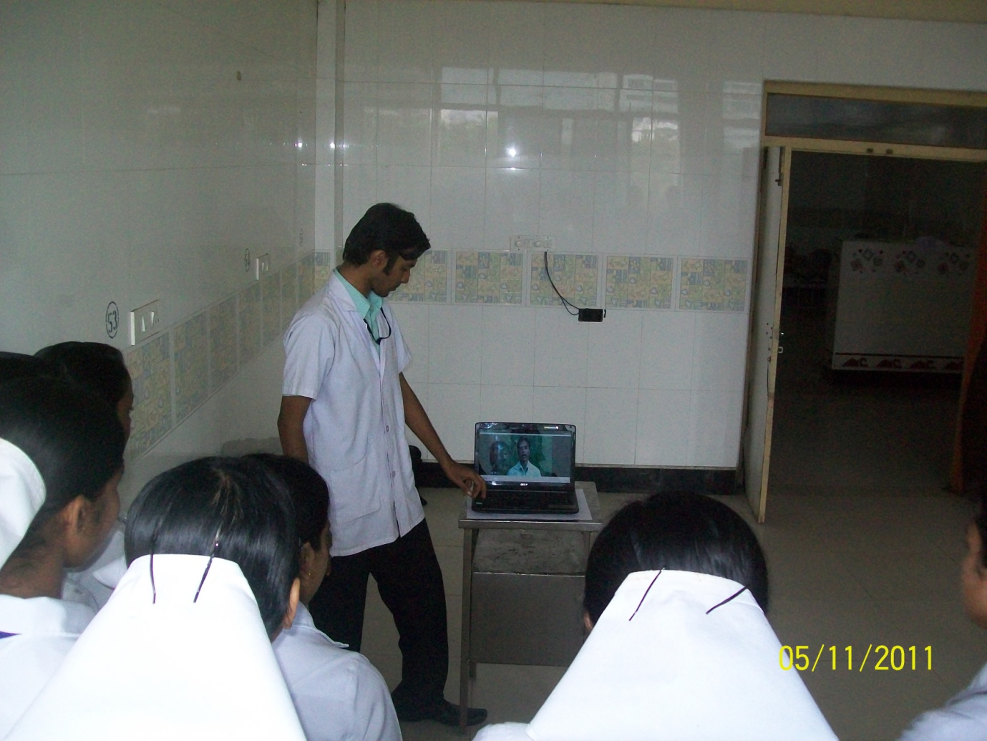
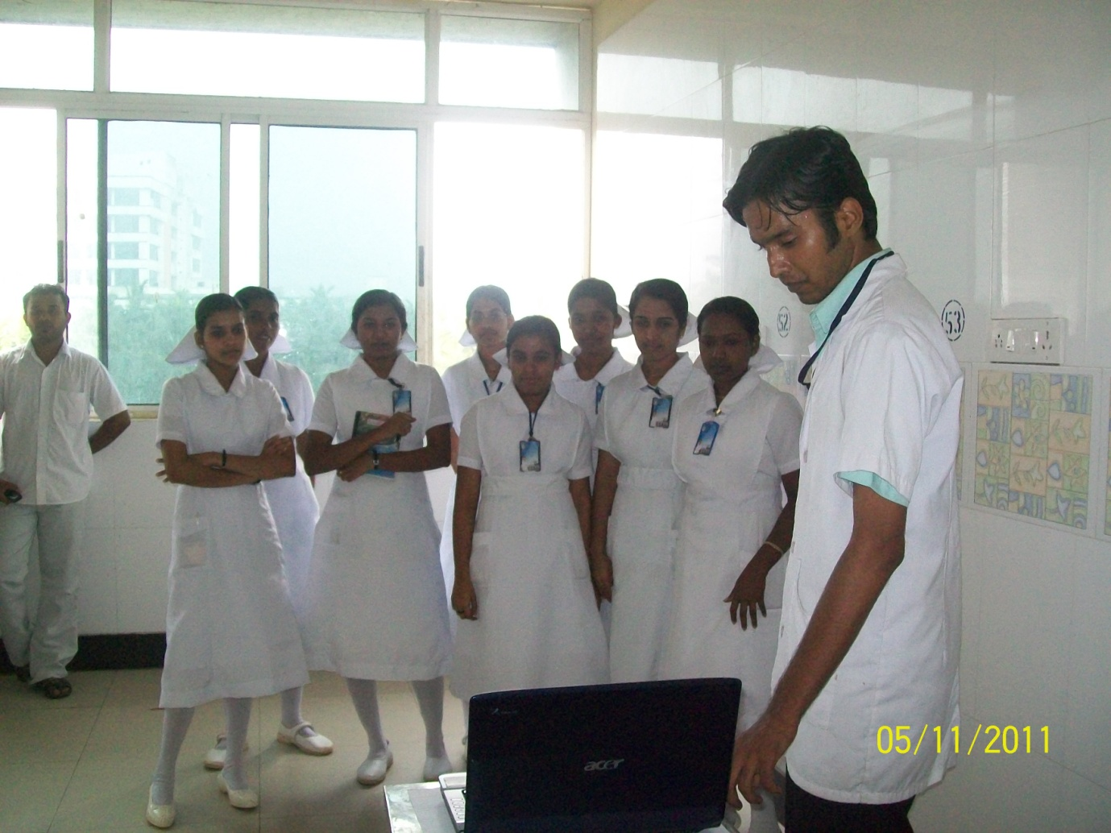
ANNEXURE IX

